**THINKBOT: REVOLUTIONIZING CHATBOT THROUGH ML AND LLM INNOVATION**

## A PROJECT REPORT

***Submitted by,***

|  |  |
| --- | --- |
| **20201COM0058** | **Darshan Gowda G** |
| **20201COM0057** | **Vishal R** |
| **20201COM9001** | **Jangam Dheeraj** |
| **20201COM0055** | **Vishwas B** |
| **20191COM0219** | **V Sankar Reddy** |

### *Under the guidance of,*

**Ms. SHASIK SALMA BEGUM**

**Assistant Professor**

***in partial fulfillment for the award of the degree of***

**BACHELOR OF TECHNOLOGY**

**IN**

**COMPUTER ENGINEERING**

**At**



**SCHOOL OF COMPUTER SCIENCE & ENGINEERING**

**PRESIDENCY UNIVERSITY**

**BENGALURU**

**JANUARY 2024**

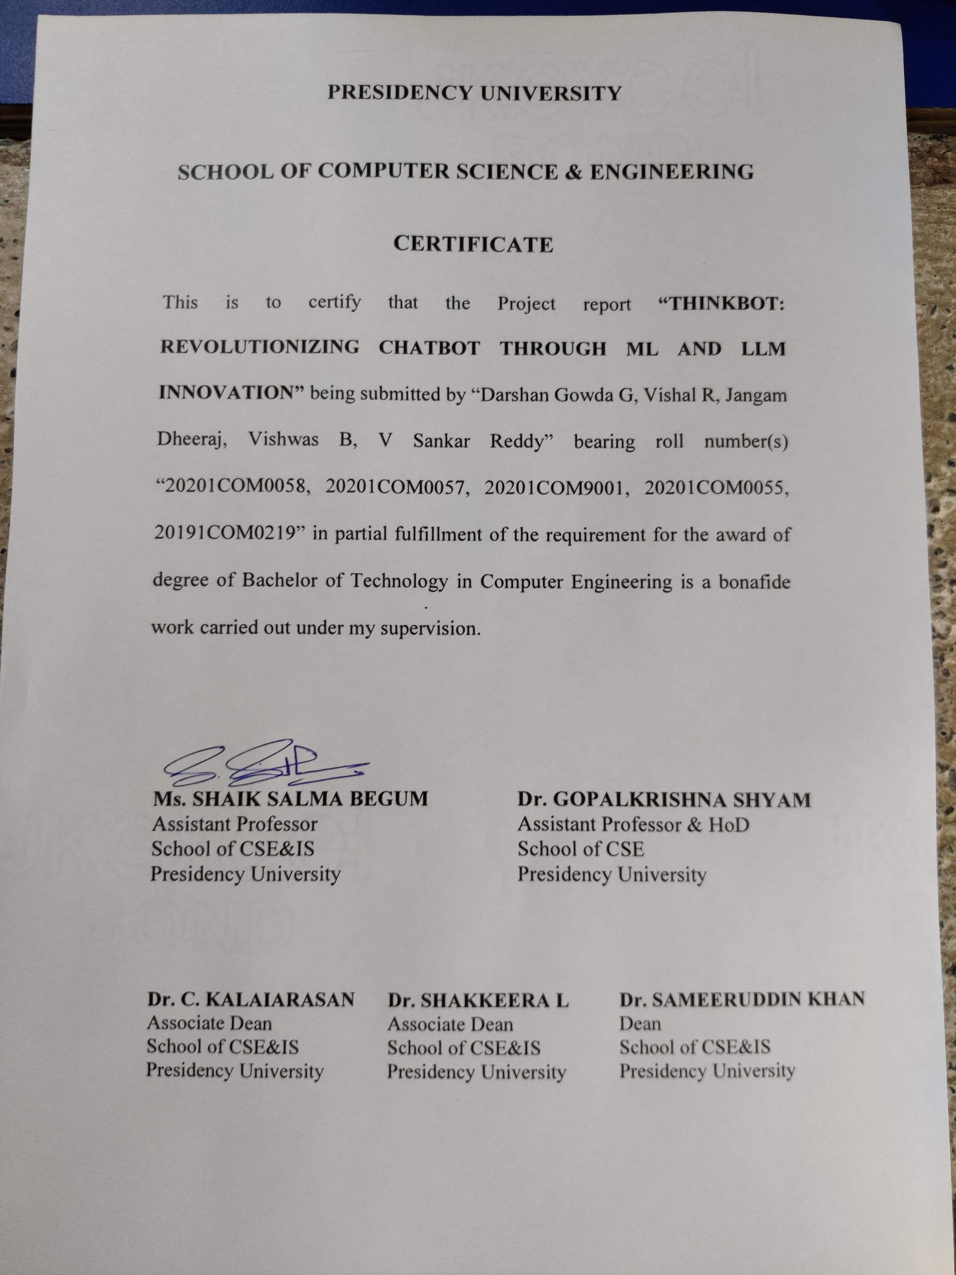

**PRESIDENCY UNIVERSITY**

**SCHOOL OF COMPUTER SCIENCE & ENGINEERING**

**DECLARATION**

We hereby declare that the work, which is being presented in the project report entitled **THINBOT: REVOLUTIONIZING CHATBOT THROUGH ML AND LLM INNOVATION** in partial fulfillment for the award of Degree of **Bachelor of Technology** in **Computer Engineering**, is a record of our own investigations carried under the guidance of **Ms. Shaik Salma Begum**, Assistant Professor, **School of Computer Science Engineering & Information Science, Presidency University, Bengaluru.**

We have not submitted the matter presented in this report anywhere for the award of any other Degree.

|  |  |  |  |
| --- | --- | --- | --- |
| **Sl. No.** | **Roll Number** | **Student Name** | **Signature** |
| 1 | 20201COM0058 | Darshan Gowda G |  |
| 2 | 20201COM0057 | Vishal R |  |
| 3 | 20201COM9001 | Jangam Dheeraj |  |
| 4 | 20201COM0055 | Vishwas B |  |
| 5 | 20191COM0219 | V Sankar Reddy |  |

**ABSTRACT**

This initiative introduces an advanced customer service chatbot that stands out from traditional text-only counterparts by incorporating a distinctive "speak aloud" feature. Driven by machine learning, the chatbot integrates the Naive Bayes, LoRA, and QLoRA algorithms to tackle global challenges in customer engagement. This entails seamlessly translating spoken inquiries into actionable responses, showcasing a high level of proficiency in delivering efficient customer support.

Going beyond conventional text interactions, the chatbot's user interface boasts a range of features, including a voice input microphone, an image-to-text converter, and a quick copy function. This comprehensive approach aims to redefine customer service, providing rapid, user-friendly, and adaptable answers to consumer queries. The use of Naive Bayes for text classification, LoRA for sentiment analysis, and QLoRA for question-answering underscores the project's commitment to a thorough and organized methodology.

Naive Bayes is chosen for its simplicity and effectiveness in text classification, enabling the chatbot to accurately discern user intents. The incorporation of LoRA enhances the chatbot's capabilities with robust sentiment analysis, enabling a nuanced understanding of user emotions. Furthermore, QLoRA leverages quantum computing principles to enhance question-answering performance, ensuring adaptability to a diverse range of user queries.

This project signifies a transformative shift in customer service provision, combining cutting-edge algorithms with a comprehensive methodology. The chatbot not only showcases the technical prowess of advanced ML algorithms but also highlights practical innovation in user-centric features. The amalgamation of Naive Bayes, LoRA, and QLoRA contributes to the chatbot's effectiveness in understanding and addressing user needs, making it a pioneering force in the evolving landscape of customer support. Rigorous testing and evaluation establish a new standard for customer service chatbots, promising improved user experiences, heightened efficiency, and unparalleled adaptability. The detailed exploration of each algorithm's role, implementation, and impact underscores the innovative features and sophisticated algorithms that position this chatbot as a trailblazer in modern customer service solutions.

**ACKNOWLEDGEMENT**

First of all, we indebted to the **GOD ALMIGHTY** for giving me an opportunity to excel in our efforts to complete this project on time.

We express our sincere thanks to our respected dean **Dr. Md. Sameeruddin Khan**, Dean, School of Computer Science Engineering & Information Science, Presidency University for getting us permission to undergo the project.

We record our heartfelt gratitude to our beloved Associate Deans  **Dr. Kalaiarasan C and Dr. Shakkeera L,** School of Computer Science Engineering & Information Science, Presidency University and **Dr. Gopalakrishna Shyam** Head of the Department, School of Computer Science Engineering & Information Science, Presidency University for rendering timely help for the successful completion of this project.

We are greatly indebted to our guide **Ms. Shaik Salma Begum**, School of Computer Science Engineering & Information Science, Presidency University for her inspirational guidance, and valuable suggestions and for providing us a chance to express our technical capabilities in every respect for the completion of the project work.

We would like to convey our gratitude and heartfelt thanks to the University Project-II Coordinators **Dr. Sanjeev P Kaulgud, Dr. Mrutyunjaya MS** and also the department Project Coordinators are **Dr. Sasidhar Babu S, Ms. Merlin Xavier, Dr. Sudha P, Ms. Yogeetha BR.**

|  |
| --- |
| **Darshan Gowda G** |
| **Vishal R** |
| **Jangam Dheeraj** |
| **Vishwas B** |
| **V Sankar Reddy** |

We thank our family and friends for the strong support and inspiration they have provided us in bringing out this project.

**LIST OF TABLES**

|  |  |  |  |
| --- | --- | --- | --- |
| **Sl. No.** | **Table Name** | **Table Caption** | **Page No.** |
| 1 | Table 1.1 | Gant Chart Table | 29 |
| 2 | Table 2.1 | Unit Testing 1 | 33 |
| 3 | Table 2.2 | Unit Testing 2 | 34 |
| 4 | Table 2.3 | Integration Testing | 35 |

**LIST OF FIGURES**

|  |  |  |  |
| --- | --- | --- | --- |
| **Sl. No.** | **Figure Name** | **Caption** | **Page No.** |
| 1 | Figure 1.1 | Lora | 21 |
| 2 | Figure 1.2 | QLora | 22 |
| 3 | Figure 1.3 | Navie Bayes | 23 |
| 4 | Figure 2.1 | Use case Diagram | 17 |
| 5 | Figure 2.2 | Web app architecture diagram | 18 |
| 6 | Figure 2.3 | Gantt Chart | 29 |
| 7 | Figure 3.1 | Home page | 48 |
| 8 | Figure 3.2 | Home page(Responsive) | 48 |
| 9 | Figure 3.3 | Login page | 49 |
| 10 | Figure 3.4 | Register page | 49 |
| 11 | Figure 3.5 | Reset page | 50 |
| 12 | Figure 3.6 | OTP page | 50 |
| 13 | Figure 3.7 | Set new password page | 51 |
| 14 | Figure 3.8 | Dashboard page | 51 |
| 15 | Figure 3.9 | Help page | 52 |
| 16 | Figure 3.10 | 404 error page | 53 |
| 17 | Figure 4.1 | Plagiarism Report | 57 |

**TABLE OF CONTENTS**

|  |  |  |
| --- | --- | --- |
| **CHAPTER NO.** | **TITLE** | **PAGE NO.** |
|  | **DECLARATION**  **ABSTRACT**  **ACKNOWLEDGMENT** | **i**  **ii**  **iii** |
| **1** | **INTRODUCTION** | 1 |
|  | 1.1 BACKGROUND | 1 |
|  | 1.2 PROBLEM STATEMENT | 2 |
|  | 1.3 SCOPE | 2 |
| **2** | **LITERATURE SURVEY** | 3 |
| **3** | **RESEARCH GAPS OF EXISTING SYATEMS** | 12 |
|  | 3.1 EXISTING METHODS | 12 |
|  | 3.2 LIMITATION OF EXISTING SYTEM | 12 |
|  | 3.3 EXISTING GAPS | 12 |
| **4** | **PROPOSED METHODOLOGY** | 13 |
|  | 4.1 ADVANTAGES | 14 |
| **5** | **OBJECTIVES** | 16 |
| **6** | **SYSTEM DESIGN & IMPLEMENTATION** | 17 |
|  | 6.1 USE CASE DIAGRAM | 17 |
|  | 6.2 ARCHITECTURE DIAGRAM | 18 |
|  | 6.3 HARDWARE AND SOFTWARE SPECIFICATIONS | 18 |
|  | 6.4 ABOUT PYTHON AND MACHINE LEARNING | 19 |
|  | 6.5 ALGORITHM DETAILS | 21 |
|  | 6.6 SOURCE CODE DETAILS | 24 |
| **7** | **TIMELINE FOR EXECUTION OF PROJECT** | 29 |
| **8** | **OUTCOMES** | 30 |
| **9** | **RESULTS AND DISCUSSIONS** | 32 |
|  | 9.1 RESULTS | 32 |
|  | 9.1.1 UNIT TESTING | 33 |
|  | 9.1.2 INTEGRATION TESTING | 34 |
|  | 9.2 DISCUSSIONS | 35 |
| **10** | **CONCLUSION** | 36 |
| **11** | **REFERENCES** | 37 |
| **12** | **APENDIX** | 40 |
|  | 1. PSEUDOCODE | 40 |
|  | 1. SCREENSHOTS | 48 |
|  | 1. ENCLOSURES | 53 |
| **13** | **PLAGIARISM REPORT** | 54 |

**CHAPTER-1**

**INTRODUCTION**

* 1. **BACKGROUND**

In the dynamic landscape of modern customer service, the imperative to meet and exceed rising consumer expectations has ushered in an era of transformative technologies. Artificial intelligence (AI) and machine learning (ML) are at the forefront of this evolution, poised as catalysts for redefining the customer support paradigm. The initiation of this project marks a dedicated exploration into creating an avant-garde customer support chatbot meticulously designed to harness the full potential of state-of-the-art machine learning techniques.

The imperative to enhance customer support processes has never been more pressing. As consumer expectations ascend to unprecedented heights, the traditional methods of service provision reveal inherent limitations. Within this context, the intersection of AI and ML emerges as a beacon of innovation, promising to revolutionize how businesses engage with their clientele.

The heartbeat of this project is the development of a cutting-edge chatbot—a technological marvel seamlessly integrating AI and ML principles. These principles are not merely an augmentation but represent a fundamental shift in the approach to customer support. The chatbot, conceptualized as an intelligent conversational agent, is envisioned to transcend conventional limitations. By leveraging the latest advancements in machine learning, it aspires to not only comprehend user queries at a profound level but also to provide tailored and nuanced solutions to the complexities inherent in customer support interactions.

This endeavour is more than a technological innovation; it's a commitment to crafting a customer support experience that anticipates and exceeds the expectations of the contemporary consumer. The project aligns itself with the pulsating currents of technological progress, aiming not just to meet the demands of today but to anticipate and shape the expectations of tomorrow. In a world where customer service is increasingly becoming a differentiator for businesses, this project positions itself at the vanguard, poised to redefine the essence of user-business interactions through cutting-edge technology and unwavering innovation.

* 1. **PROBLEM STATEMENT**

Existing chatbots need help with complex issues due to rudimentary programming and limited data training, often requiring human intervention for escalated cases and undermining potential cost savings. Moreover, their reliance on text-based interactions neglects alternative modes specific demographics favor. In response, our project aims to develop an advanced machine learning-driven chatbot capable of nuanced understanding and precise resolutions across diverse input formats. This initiative seeks to redefine customer support by addressing the deficiencies of current systems and offering intuitive, engaging, and accessible services. The project introduces a groundbreaking "speak aloud" feature to bridge the gap in user-friendly interactions, revolutionizing traditional customer support dynamics.

* 1. **SCOPE**

The project delves into the transformation of customer service by addressing the limitations of traditional chatbots. Introducing the "speak aloud" feature elevates the chatbot's capabilities, allowing users to engage through spoken queries, thus enhancing the overall user experience. Integrating a microphone expands the chatbot's adaptability to diverse communication preferences.

In addition to voice interactions, the project enriches the user interface with features like an image-to-text converter and a quick copy functionality. The image-to-text converter broadens the chatbot's scope by accommodating visual inputs, while the quick copy feature streamlines information retrieval for increased efficiency. This comprehensive approach aims to redefine customer service dynamics, offering users a more natural and versatile interaction platform. The project seeks to address current limitations and anticipates future advancements in the ever-evolving landscape of artificial intelligence and machine learning.

**CHAPTER-2**

**LITERATURE SURVEY**

1. **Customer Support Chatbot using Machine Learning**

**Journal Details:** Published in 2019 by R Madana Mohana, Pitty Nagarjuna, P Lalitha Kumari

**Abstract:** In customer support, chatbot by using machine learning customer can converse by a chatbot and acquire the query intent information. With the enhancement of globalization and industrialization, it becomes a problem for enterprises to interact with the customer and listen to their difficulties to a big extent. Chatbots make ease the pain that the industries nowadays facing. The aim of this chatbot is to support and reply to the client by giving him/her the relevant intent depending on the query request from the customers.

**Advantages:**

* **Efficient Problem Resolution:** Customer Support Chatbots using NLP and Classification algorithms can quickly understand and categorize user queries. This efficiency leads to faster problem resolution, as the chatbot can provide relevant information or direct users to the appropriate resources promptly.
* **Consistency in Responses:** Chatbots ensure consistency in responses by following predefined algorithms. This consistency helps in maintaining a uniform service quality and ensures that users receive accurate and standardized information regardless of the time or day.
* **Data-Driven Improvements:** Machine Learning algorithms enable continuous learning and adaptation. Customer interactions with the chatbot generate data that can be analyzed to identify patterns and trends. This data-driven approach allows for ongoing improvements in the chatbot's performance, enhancing its ability to handle a variety of queries effectively.

**Limitations:**

* **Lack of Human Understanding:** While NLP enables chatbots to understand and generate human-like language, it may still struggle with nuanced or complex queries. The chatbot might misinterpret user intent, leading to inaccurate responses, especially when faced with ambiguous language or unique situations.
* **Limited Context Awareness:** Chatbots may struggle to maintain context over extended conversations. They might not understand references made earlier in the conversation, leading to disjointed interactions. Improving context awareness is a challenging task, and limitations in this area can impact the overall user experience.
* **Dependency on Training Data Quality:** The effectiveness of machine learning models heavily relies on the quality and representativeness of the training data. If the data used to train the chatbot is biased or incomplete, the model may produce inaccurate or unfair responses, potentially reinforcing existing biases.
* **Inability to Handle Emotional Nuances:** Understanding and appropriately responding to emotions expressed by users is a significant challenge for customer support chatbots. They may struggle to recognize and respond empathetically to emotions, leading to a less personalized and emotionally resonant user experience compared to human agents.

1. **A Hybrid Approach to Customer Service**

**Journal Details:** Published in 2022 by Rejwan Bin Sulaiman

**Abstract:** Providing the best customer experience is one of the primary concerns for the firms that are based online. The advancement of machine learning is revolutionizing the company's attitude towards the client through improving the service quality by implementing chatbot solutions, which gives the user instant and satisfactory answers to their enquiries. The acceptance of this technology is increasing with the new improvements and efficiency of the chatbot system. This thesis paper will cover the concept of chatbot system for the company, as a use case we took AK traders Ltd. It involves the research work on various chatbot technologies available and based on research, use them to develop a chatbot system for the company. This system will work based on the text as a conversational agent that can interact with humans by natural language. The main objective project is to develop the chatbot solution that could comply with complex questions and logical output answers in a well-defined approach. The ultimate goal is to give high-quality results (answers) based on user input (question). For the successful implementation of this project, we have undertaken an in-depth analysis of the various machine learning techniques available and followed well-structured implementation to figure out the best solution for the company. The primary concern of this project includes natural language processing (NLP), machine learning and the vector space model (VSM). The outcome of the project shows the problem-solving technique for the implementation of the chatbot system for the company at a reasonable quality level.

**Advantages:**

* **Enhanced Understanding:** Deep learning improves chatbots' understanding of user intent through NLP, allowing for nuanced conversations.
* **Higher Accuracy:** Deep learning architectures enhance the accuracy of responses, learning complex patterns for more precise and context-aware interactions.
* **Adaptability:** The hybrid approach enables continual learning, adapting to evolving language and user needs.
* **Advanced Language Processing:** Deep learning enhances natural language processing, allowing chatbots to comprehend and generate human-like language more effectively.

**Limitations:**

* **Data Dependency:** Deep learning models require substantial data, and performance hinges on the availability of diverse and high-quality training data.
* **Resource Intensive:** Implementing deep learning can be computationally demanding, requiring powerful hardware and potentially increasing operational costs.
* **Interpretable Complexity:** The complex nature of deep learning models may hinder interpretability, making it challenging to understand how decisions are reached or troubleshoot errors.

1. **Seq2Seq AI Chatbot with Attention Mechanism**

**Journal Details:** Published in 2020 by Abonia Sojasingarayar

**Abstract:** Intelligent Conversational Agent development using Artificial Intelligence or Machine Learning technique is an interesting problem in the field of Natural Language Processing. In many research projects, they are using Artificial Intelligence, Machine Learning algorithms and Natural Language Processing techniques for developing conversation/dialogue agent. In the past, methods for constructing chatbot architectures have relied on hand-written rules and templates or simple statistical methods. With the rise of deep learning, these models were quickly replaced by end-to-end trainable neural networks around 2015. More specifically, the recurrent encoder-decoder model [Cho et al., 2014] dominates the task of conversational modeling. This architecture was adapted from the neural machine translation domain, where it performs extremely well. Since then a multitude of variations[Serbanetal.,2016]and features were presented that augment the quality of the conversation that chatbots are capable of[Richard.,2017].Among current chatbots, many are developed using rule-based techniques, simple machine learning algorithms or retrieval based techniques which do not generate good results. In this paper, I have developed a Seq2Seq AI Chatbot using modern-day techniques. For developing Seq2Seq AI Chatbot, We have implemented encoder-decoder attention mechanism architecture. This encoder-decoder is using Recurrent Neural Network with LSTM (Long-Short-Term-Memory) cells. These conversation agents are predominately used by businesses, government organizations and non-profit organizations. They are frequently deployed by financial organizations like bank, credit card companies, businesses like online retail stores and start-ups.

**Advantages:**

* **Contextual Understanding:** Seq2Seq models excel in capturing contextual dependencies, enhancing chatbots' comprehension of user queries.
* **Variable-Length Input:** Effective handling of variable-length input sequences allows flexibility in user interactions.
* **Natural Language Generation:** Seq2Seq facilitates natural language generation, enabling coherent and contextually relevant responses.
* **Sequential Learning:** Ideal for tasks requiring sequential patterns, Seq2Seq excels in maintaining conversation flow and coherence.

**Limitations:**

* **Training Data Quality:** Performance heavily relies on the quality and diversity of training data.
* **Complexity:** Implementation can be complex, requiring careful architecture design and parameter tuning.
* **Context Loss:** May struggle with maintaining long-term context, potentially leading to information loss in extended conversations.

1. **Building Intelligent Chatbot for Customer service using Reinforcement Learning**

**Journal Details:** Published in 2022 by Andreas Metzger, Jone Bartel, Jan Laufer

**Abstract:** Deep Reinforcement Learning (Deep RL) is increasingly used to cope with the open-world assumption in service-oriented systems. Deep RL was successfully applied to problems such as dynamic service composition, job scheduling, and offloading, as well as service adaptation. While Deep RL offers many benefits, understanding the decision-making of Deep RL is challenging because its learned decision-making policy essentially appears as a black box. Yet, understanding the decision-making of Deep RL is key to help service developers perform debugging, support service providers to comply with relevant legal frameworks, and facilitate service users to build trust. We introduce Chat4XAI to facilitate the understanding of the decision-making of Deep RL by providing natural-language explanations. Compared with visual explanations, the reported benefits of natural-language explanations include better understandability for non-technical users, increased user acceptance and trust, as well as more efficient explanations. Chat4XAI leverages modern AI chatbot technology and dedicated prompt engineering. Compared to earlier work on natural-language explanations using classical software-based dialogue systems, using an AI chatbot eliminates the need for eliciting and defining potential questions and answers up-front. We prototypically realize Chat4XAI using OpenAI's ChatGPT API and evaluate the fidelity and stability of its explanations using an adaptive service exemplar.

**Advantages:**

* **Adaptive Responses:** Reinforcement learning allows chatbots to adapt responses based on user feedback, enhancing performance over time.
* **Continuous Improvement:** Interaction with users provides ongoing learning, enabling the chatbot to refine its strategies for better service.
* **Personalized Interactions:** Adaptive models can tailor responses to individual user preferences, providing a more personalized customer experience.

**Limitations:**

* **Data Efficiency:** Training RL models may require extensive user interactions, potentially making them data-intensive.
* **Policy Exploration:** Balancing exploration and exploitation during learning can be challenging, impacting the efficiency of the learning process.
* **User Feedback Quality:** The effectiveness of RL depends on the quality and relevance of user feedback, which may vary in practice.

1. **Hybrid Chatbots for Customer Service: Integrating Rule-Based and ML Approaches**

**Journal Details:** Published in 2020 by Rejwan Bin Sulaiman

**Abstract:** Providing the best customer experience is one of the primary concerns for the firms that are based online. The advancement of machine learning is revolutionising the company's attitude towards the client through improving the service quality by implementing chatbot solutions, which gives the user instant and satisfactory answers to their enquiries. The acceptance of this technology is increasing with the new improvements and efficiency of the chatbot system. This thesis paper will cover the concept of chatbot system for the company, as a use case we took AK traders Ltd. It involves the research work on various chatbot technologies available and based on research, use them to develop a chatbot system for the company. This system will work based on the text as a conversational agent that can interact with humans by natural language. The main objective project is to develop the chatbot solution that could comply with complex questions and logical output answers in a well-defined approach. The ultimate goal is to give high-quality results (answers) based on user input (question). For the successful implementation of this project, we have undertaken an in-depth analysis of the various machine learning techniques available and followed well-structured implementation to figure out the best solution for the company. The primary concern of this project includes natural language processing (NLP), machine learning and the vector space model (VSM). The outcome of the project shows the problem-solving technique for the implementation of the chatbot system for the company at a reasonable quality level

**Advantages:**

* **Robustness:** Integrating rule-based and ML methods combines the reliability of predefined rules with the adaptability of machine learning, creating a robust system.
* **Interpretability:** Rule-based components provide interpretability, aiding in understanding and debugging.
* **Customization:** Hybrid models allow for easy customization by adjusting rules or retraining ML components to meet specific business needs.
* **Efficient Handling:** Rules efficiently manage common queries, reducing the computational load on ML components.

**Limitations:**

* **Maintenance Overhead:** Managing and updating rules and ML models can introduce maintenance complexities.
* **Potential Overreliance:** Overreliance on rules may limit adaptability, especially in handling novel or evolving scenarios.
* **Integration Challenges:** Harmonizing rule-based and ML components may pose integration challenges, impacting system coherence and performance.

1. **Towards Empathetic Chatbots for Customer Service**

**Journal Details:** Published in 2019 by Akshay Agarwal, Shashank Maiya, Sonu Agarwal

**Abstract:** Customer service is a setting that calls for empathy in live human agent responses. Recent advances have demonstrated how open-domain chatbots can be trained to demonstrate empathy when responding to live human utterances. We show that a blended skills chatbot model that responds to customer queries is more likely to resemble actual human agent response if it is trained to recognize emotion and exhibit appropriate empathy, than a model without such training. For our analysis, we leverage a Twitter customer service dataset containing several million customer<- >agent dialog examples in customer service contexts from 20 well-known brands.

**Advantages:**

* **Enhanced User Experience:** Incorporating sentiment analysis and emotional intelligence improves chatbots' ability to respond empathetically, enhancing user satisfaction.
* **Effective Problem Resolution:** Understanding user emotions allows for more precise issue identification and tailored problem-solving.
* **Customer Retention:** Empathetic responses contribute to positive customer experiences, fostering loyalty and retention.
* **Brand Perception:** Empathetic chatbots contribute to a positive brand image by demonstrating understanding and care.

**Limitations:**

* **Complexity of Emotions:** Accurately interpreting nuanced emotions can be challenging, leading to potential misinterpretations.
* **Inconsistencies in User Expressions:** Variability in how users express emotions may affect the reliability of sentiment analysis.
* **Resource Intensive:** Implementing emotional intelligence may require additional computational resources, impacting system efficiency and scalability

1. **College Enquiry Chatbot using Rasa Framework**

**Journal Details:** Published in 2021 by Siddhant Meshram, Namit Naik, Megha VR, Tanmay More, Shubhangi Kharche

**Abstract:** The growth of technologies like Artificial Intelligence (AI), Big Data & Internet of Things (IoT), etc. has marked many advancements in the technological world since the last decade. These technologies have a wide range of applications. One such application is “Chatterbot or “Chatbot”. Chatbots are conversational AIs, which mimics the human while conversing & eliminates the need of human by automating mundane tasks. In the study undertaken, we have created a chatbot in education domain & it is named as “College Enquiry Chatbot”, This chatbot is a web-based application that analyses and understands user's queries and provides an instant and accurate response. Rasa technology is used to construct this chatbot. It's an open-source technology, which uses its two main packages i.e., Rasa Core & Rasa Natural Language Understanding (NLU) in order to build a Contextual AI Chatbot. NLU is used to infer the intent and to extract the necessary entities from user input & the Rasa Core provides the output by building a probabilistic model with the help of Recurrent Neural Network (RNN). Evaluation of the model is done by getting a confusion matrix and performance measures like Precision, Accuracy & F1 Score which come out to be 0.628, 0.725 and 0.669 respectively on average basis. This chatbot's accuracy, lack of dependability on human resources, 24 x 7 accessibility and low maintenance creates various opportunities for its implementation. This conversational agent can not only be used in educational institutions but also in places where enquiry becomes a tedious task.

**Advantages:**

* **Reduced Dependence on Human Resources**: By automating mundane tasks and providing instant responses, the chatbot reduces the need for human intervention in handling routine enquiries, leading to increased efficiency.
* **Low Maintenance:** The chatbot, built on the Rasa framework, is likely to require low maintenance, making it a cost-effective and sustainable solution for handling inquiries over an extended period.

**Limitations:**

* + **Accuracy Challenges:** The average accuracy of the chatbot may be a limitation, as it indicates a certain level of misclassification or uncertainty in understanding user intents and providing accurate responses.
  + **Dependency on Training Data Quality:** The performance of the chatbot heavily depends on the quality and diversity of the training data. Insufficient or biased training data may lead to limitations in understanding varied user queries.
  + **Complexity in Handling Ambiguous Queries:** The chatbot may face challenges in handling ambiguous or complex queries where user intents are not clear, potentially resulting in less accurate responses in such scenarios.

**CHAPTER-3**

**RESEARCH GAPS OF EXISTING SYSTEM**

**3.1. Existing Methods**

Current customer support chatbots typically use a mix of machine learning tools. They often rely on natural language processing for better conversations, using models like GPT-3 to understand context. Intent recognition, figuring out what the user wants, involves smart algorithms. Some chatbots learn from pre-existing models. They also use a combination of rule-based and learning-based methods for adaptability. To make conversations more personal, sentiment analysis is applied to understand user feelings. All these methods work together to make sure chatbots are good at handling different types of customer questions and improving over time.

**3.2. LIMITATION OF EXISTING SYSTEMS**

* Struggles in handling ambiguous queries or situations.
* Risk of overfitting to training data or being too generic.
* Pre-trained models may not be tailored well to the specific domain of customer support.

**3.3. EXISTING GAPS**

* + **Understanding User Inputs:** Existing models struggle with various inputs, like speech and images, limiting their flexibility.
  + **Recognizing Emotions:** Many chatbots have difficulty understanding and responding to users' emotions, missing a personal touch.
  + **Making Conversations Flow:** Maintaining context during extended conversations remains a challenge, affecting the chatbot's coherence.
  + **Data Quality Impact:** Machine learning models heavily rely on high-quality training data, introducing potential biases and limitations.
  + **Handling Ambiguity:** Existing models face challenges with ambiguous or complex queries, potentially leading to inaccurate responses.

**CHAPTER-4**

**PROPOSED METHODOLOGY**

Our project, "Customer Support Chatbot," adopts an advanced approach featuring a fine-tuned Mistral-based Ollama model, along with the incorporation of Lora and Qlora algorithms. The Mistral-based Ollama model serves as the foundation, fine-tuned to optimize language understanding. The integration of Lora and Qlora algorithms further enhances the chatbot's question-answering capabilities, creating a unique and sophisticated language processing framework. This comprehensive methodology ensures the chatbot's adeptness in interpreting user intent and delivering contextually precise responses. By leveraging these cutting-edge technologies, our proposed work aims to redefine customer support interactions, providing an intelligent and tailored solution for effective communication and issue resolution.

* User Engagement
* Intent Recognition
* Response Generation
* Response Delivery
* Continuous Learning

**4.1. ADVANTAGES**

* **Enhanced Customer Engagement:** The integration of ML models ensures a sophisticated understanding of user intent, fostering more engaging and meaningful conversations with customers. This heightened engagement contributes to a positive user experience, leading to increased customer satisfaction and loyalty.
* **Efficient Problem Resolution:** Leveraging Naive Bayes, Lora, and Qlora algorithms enables the chatbot to swiftly and accurately identify customer issues. This efficiency in problem resolution translates to quicker turnaround times, reducing customer frustration and improving overall service quality.
* **Improved Response Time:** Automation driven by ML algorithms significantly improves response times in customer support. The chatbot can promptly address queries, providing instant assistance and elevating the overall efficiency of the support system.
* **Multi-Algorithmic Approach:** The incorporation of diverse algorithms, including Naive Bayes, Lora, and Qlora, equips the chatbot with a versatile toolkit. This multi-algorithmic approach enables the system to handle a wide range of customer inquiries with precision and adaptability.
* **Personalized Assistance:** The fine-tuned Mistral-based Ollama model allows the chatbot to offer personalized assistance based on individual user interactions. This personalized touch enhances the user experience, making customers feel understood and valued by the automated support system.
* **Intent Recognition Accuracy:** ML-based intent recognition mechanisms ensure a high level of accuracy in understanding customer queries. This precision reduces misinterpretations, enabling the chatbot to provide relevant and contextually appropriate responses, thereby enhancing the overall effectiveness of customer interactions.
* **Natural Language Understanding:** Integration of TF-IDF enhances the chatbot's natural language understanding capabilities. This feature allows the system to grasp the nuances of user input, facilitating more context-aware responses and creating a more seamless and human-like conversation experience for customers.
* **Scalability:** The modular design with multiple algorithms ensures scalability, allowing the chatbot to efficiently handle increased usage and a growing user base. This adaptability is crucial for businesses experiencing fluctuations in customer interaction volume, ensuring consistent performance.
* **Cost-Efficiency:** The automation of customer support tasks through ML models reduces the need for extensive human intervention, resulting in cost savings for the organization. This cost-efficiency is achieved without compromising the quality and effectiveness of customer service.
* **Continuous Learning:** ML models enable the chatbot to continuously learn from user interactions. This iterative learning process allows the system to adapt to changing customer preferences and trends, ensuring that it remains up-to-date and relevant over time.
* **Versatility Across Platforms:** The chatbot's design allows it to seamlessly integrate with various platforms and communication channels. This versatility ensures a consistent and efficient customer support experience, whether users engage with the chatbot through websites, mobile apps, or other communication channels.
* **Data Security:** Advanced algorithms are employed to handle customer data securely. The chatbot adheres to robust data protection measures, ensuring the confidentiality and integrity of customer information and aligning with regulatory standards.
* **Feedback Integration:** The chatbot system incorporates user feedback into its learning process. This feedback loop allows for continuous improvement, enabling the chatbot to refine its responses, learn from user experiences, and enhance its overall performance based on real-time user input.

**CHAPTER-5**

**OBJECTIVES**

#### **1.5.1 Enhance User Interaction**

* Implement a "speak aloud" feature to facilitate spoken queries.
* Integrate a microphone for voice input, expanding interaction options.
* Develop an image-to-text converter for diverse input methods.

#### **1.5.2 Improve Flexibility and Precision**

* Employ Machine Learning (ML) techniques for language understanding.
* Combine Language Model (LM) methods to ensure precise responses.
* Implement a quick copy feature for efficient information retrieval.

**CHAPTER-6**

**SYSTEM DESIGN & IMPLEMENTATION**

**6.1. USE CASE DIAGRAM**

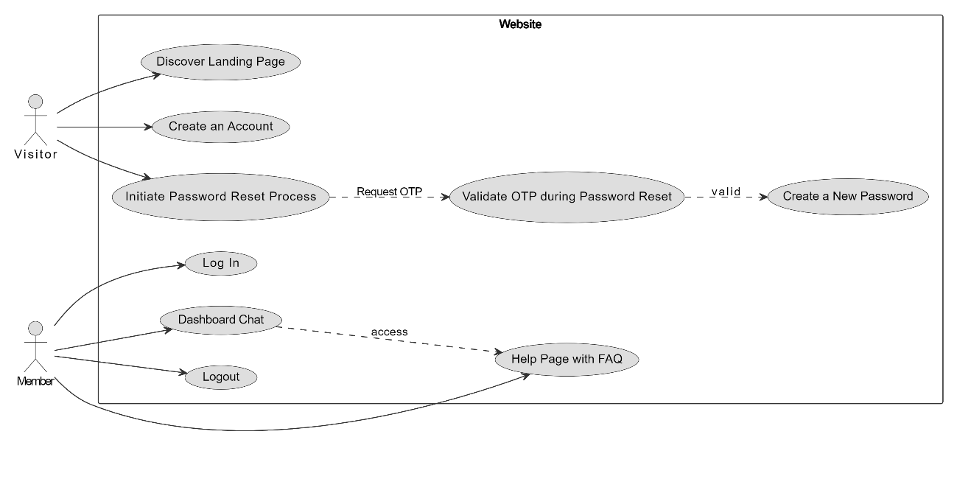

Fig 2.1: Use case diagram

Our Customer Support Chatbot with ML! Whether you're a visitor or a registered member, our platform is designed to cater to your needs. As a visitor, you can explore our home page and, if interested, access our secure login page for more information. For our valued members who have successfully registered, a world of benefits awaits you. Simply log in to unlock your personalized dashboard, offering exclusive features and content tailored just for you. Our intelligent chatbot, powered by Machine Learning, is at your service throughout your journey. Whether it's providing information to visitors or assisting members with their queries, our chatbot ensures a seamless and efficient support experience.

**6.2. ARCHITECTURE DIAGRAM**

When a user inputs a query, our advanced Machine Learning (ML) model takes charge. If the inquiry pertains to order-related information, the ML model seamlessly interfaces with the database, retrieving the latest status and relevant details. This ensures accurate and up-to-date responses tailored to the user's specific order inquiries. Additionally, our fine-tuned Mistral model refines the context and intricacies of the user's request, enhancing the understanding of nuanced queries. Once the ML model has processed the information and fine-tuned it through Mistral, a coherent and contextually rich response is generated and presented to the user. This dynamic interaction showcases the power of intelligent models working harmoniously to deliver precise and timely information.

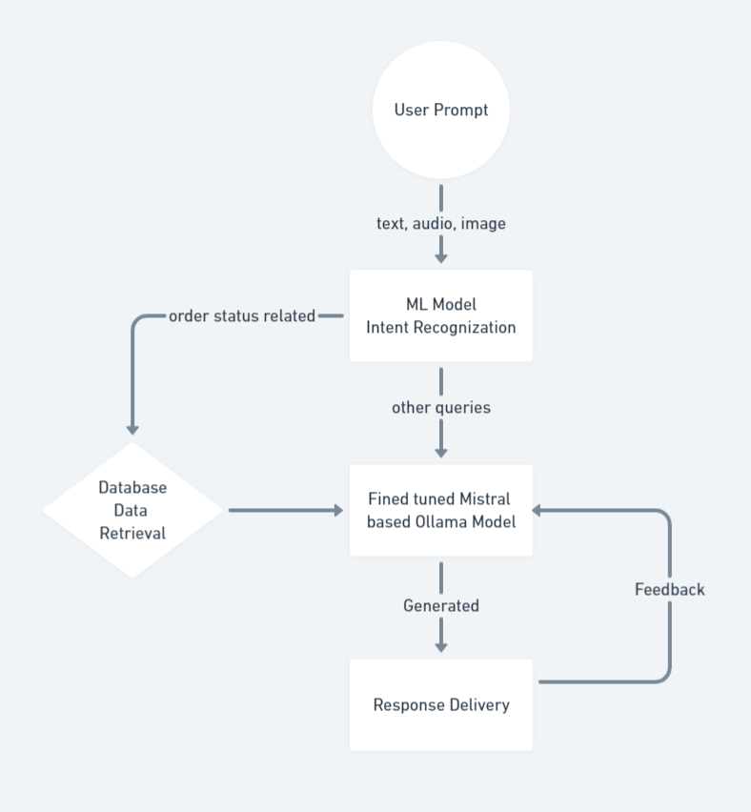

Fig 2.2: Web app architecture diagram

**6.3. HARDWARE AND SOFTWARE SPECIFICATIONS:**

* **Hardware Requirements:**

|  |  |
| --- | --- |
| * Processor | * Intel i7/M1 |
| * RAM | * 12GB |
| * ROM | * 500GB |

* **Software Requirements:**

|  |  |
| --- | --- |
| * Operating system | : Windows 10 and above/ MacBook |
| * IDE | : Visual Studio Code |
| * Front-end | : HTML, CSS, JS |
| * Server-side programming | : Python |
| * Database | : MongoDB |
| * Other libraries | : Pandas, Flask, Flask-Cors, Flask-session, Pymongo, Scikit-Learn, Joblib |

**6.4. ABOUT PYTHON AND MACHINE LEARNING**

1. **Python:**

Python is an interpreted, object-oriented, high-level, dynamically semantic programming language. It is particularly desirable for Rapid Application Development as well as for usage as a scripting or glue language to tie existing components together due to its high-level built-in data structures, dynamic typing, and dynamic binding. Python’s straightforward syntax emphasizes readability and makes it simple to learn, which lowers the cost of program maintenance. Python’s support for modules and packages promotes the modularity and reuse of code in programs. Both source code and binary versions of the comprehensive standard library and the python interpreter are available. The edit-test-debug cycle is extraordinarily quick because there is no compilation phase. Python programs are simple to debug since a segmentation failure is never caused by a bug or incorrect input. Instead, if the interpreter detects a mistake, an exception is raised by it. The interpreter produces a stack trace if the program doesn’t catch the exception. Setting breakpoints, evaluating arbitrary expressions, inspecting local and global variables, stepping through the code one line at a time, and other features are all possible with a source level debugger. Python’s ability to do introspection is demonstrated by the debugger, which is developed in python. On the other hand, adding a few print statements to the source code is frequently the quickest way to debug a program due to the short edit-test-debug cycle. It is available for free distribution on all popular platforms.

1. **Machine Learning:**

An area of artificial intelligence (AI) called machine learning is devoted to creating software programs that, without being explicitly coded, learn from data over time and become more accurate.

An algorithm is a series of statistical processing processes in data science. In machine learning, algorithms are ‘trained’ to sift through vast volumes of data in search of patterns and characteristics in order to derive conclusion and forecasts based on fresh data. As it analyses more data, a smarter algorithm will provide conclusions and predictions that are more accurate.

Machine learning examples are all round us now. When we speak to digital assistants, they respond by playing music and doing web searches. websites provide recommendations for goods, films, and music based on what we’ve previously purchased, viewed, or listened to. Our floors are vacuumed by robots while we spend our time doing greater things. Unwanted emails are prevented from entering our inboxes by spam detectors. Systems for analyzing medical images assist clinicians in finding tumors they have missed. And the first autonomous vehicles are now travelling on public roads.

We may anticipate more. Machine learning will increase productivity in both our personal and professional lives as big data continue to grow, computers get more powerful and accessible, and data scientists continue to create more effective algorithms.

The working of machine learning

Building a machine learning application (or model) involves four simple stages. Data Scientists who closely collaborate with the business executives for whom the model is being produced often carry out the tasks.

Step 1: Select and prepare a training data set

A data set used for training is a sample of the data that will be ingested by the machine learning model to address the issue at hand. In certain circumstances, the training data is “tagged” to draw attention to the traits and categories the model will need to recognize. Since some of the data is unlabeled, the model will have to extract those characteristics and make its own classifications.

Step 2: Choose an algorithm to run on the training data set

A series of statistical processing stages make up an algorithm. The kind of algorithm used relies on the quantity and kind of data (labeled or unlabeled) in the training data set, as well as the task at hand.

The following are examples of machine learning algorithms frequently used with labeled data:

* **Regression algorithms**
* **Decision trees**
* **Instance-based algorithms**

Algorithms for use with unlabeled data include the following:

* **Clustering algorithms**
* **Association algorithms**
* **Neural Networks**

Step 3: Training the algorithm to create the model

Iteratively running variables through the algorithm, comparing the output with the expected results, adjusting weights and biases within the algorithm that might produce a more accurate result, and then running the variables through the algorithm once more until the algorithm consistently returns the right answer.

Step 4: Using and improving the model

The model must then be used with fresh data, and ideally it will do so over time while also becoming more accurate and efficient. The problem that has to be solved will determine where the fresh data originates from. A machine learning model used to operate a robot hoover. Cleaner, for instance, may ingest data from real-world interactions with moving furniture or new objects in the room, but a machine learning model used to identify spam will absorb messages.

**6.5. ALGORITHM DETAILS**

1. **Lora (Low Rank Adaption Method)**

It is a specific approach to fine-tuning a 16-bit transformer model with a technique named QLORA (Quantized LOng RAge). QLORA aims to address the issue of catastrophic forgetting during fine-tuning by introducing a mechanism to retain the original weights while selectively updating a smaller set of parameters.

In the context of fine-tuning, catastrophic forgetting refers to the phenomenon where a model loses knowledge of its initial training data when adapting to new information. QLORA mitigates this by freezing the original weights (W0) and introducing additional weights (∇W) to the model. These new weights are determined by the product of two matrices, B and A, with dimensions (d x r) and (r x k) respectively, where 'r' represents the rank of the update matrices.

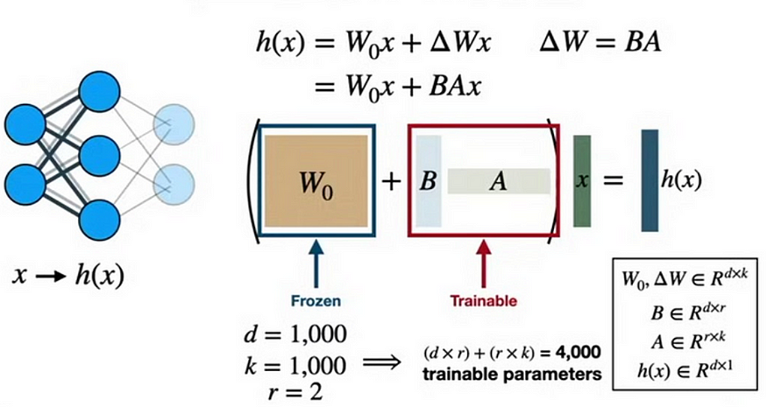

Fig 1.1: Lora

The key innovation lies in the intentional restriction of the rank 'r' to a small value (in this case, 2). A lower rank results in smaller update matrices and, consequently, fewer trainable parameters. By doing so, the model maintains a reduced set of trainable parameters, specifically ((d + k) x r), as opposed to the original (d x k) parameters. This reduction is advantageous for efficiency, as fewer parameters lead to faster training and less computational demand.

The strategy of freezing the majority of the parameters and introducing a limited number of new weights helps prevent catastrophic forgetting, allowing the model to adapt to new information without compromising its previously learned knowledge. This approach strikes a balance between incorporating new information and retaining the valuable knowledge encoded in the original weights, making it a practical solution for fine-tuning in scenarios where preserving prior learning is crucial. The intentional quantization to 16 bits also indicates a focus on computational efficiency and potential deployment on resource-constrained devices or systems.

1. **QLoRA (Quantiszed Low Rank Adaption Method)**

The described approach involves a 4-bit transformer model and introduces QLoRA, a fine-tuning technique that combines high-precision computing with low-precision storage. The objective is to maintain model performance and accuracy while minimizing model size. This strategy aligns with the broader trend in machine learning towards efficient deployment on resource-constrained devices.

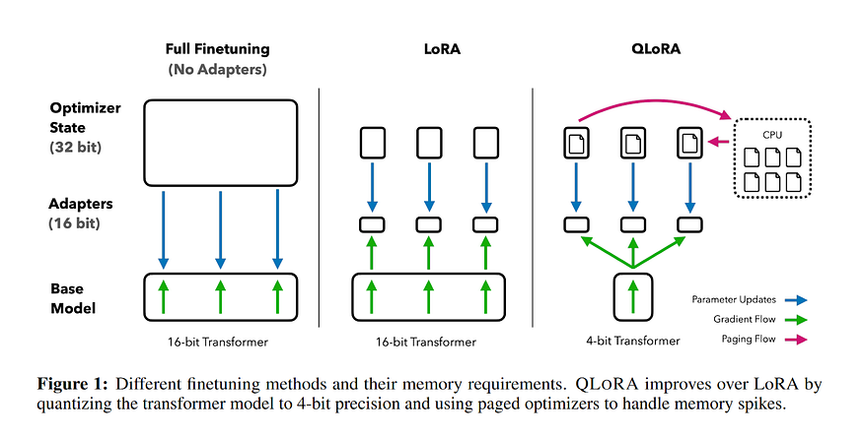

Fig 1.2: QLora

QLoRA leverages LoRA as an accessory, suggesting the use of Long-Range communication technology to address errors introduced during quantization. Quantization involves reducing the bit precision of model parameters, potentially leading to accuracy loss. By combining high-precision computing and low-precision storage, QLoRA strikes a balance between computational efficiency and model accuracy. This approach is particularly beneficial for applications where both model size and performance are critical considerations, such as deployment on edge devices or systems with limited resources.

1. **Naive Bayes:**

It is a classification methos built on the bayes theorem with the assumption of predictor independence. A naïve bayes classifier, to put it simply, believes that the existence of one feature in a class has nothing to do with the presence of any other feature.

An NB model is simple to construct and is especially beneficial for very huge datasets. Along with being straightforward, Naïve Bayes is known to perform better than even the most complex classification techniques. Bayes theorem provides a way of computing posterior probabability P(C|X) from P(C), P(X) and P(X|C). Look at the equation below:

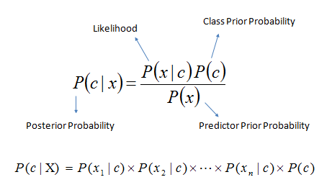

Fig 1.3: Navie Bayes

Above,

* P(C|X) is the probability of class (C, target) given predictor (X, attributes).
* P(C) is the prior probability of class.
* P(X|C) is the likelihood which is the probability of the predictor given class.
* P(X) is the prior probability of the predictor.

**Naïve Bayes Algorithms Procedure:**

Step 1: of the Naïve Bayes Algorithms Procedure is to create a frequency table out of the data set.

Step 2: Create a likelihood table by calculating probabilities such as the possibility of an overcast day being 0.29 and the probability of playing being 0.64.

Step 3: Next, get the posterior probability for each class using the Naïve Bayesian equation. The result of the prediction is the class with the highest posterior probability.

A similar approach is used by the Naïve Bayes to forecast the likelihood of various classes based on various attributes. This approach is frequently employed in issues involving many classes and text classification(nlp).

**6.6. SOURCE CODE DETAILS**

* **Flask library**

Python is used to create the Flask web application framework. Flask was developed by Armin Ronacher, who was a part of the Pocco (Python Community) group. The foundation for Flask is built upon the Werkzeug WSGI toolkit and the Jinja2 template engine, both of which are projects under Pocco.

* **WSGI**

For the creation of Python web applications, the Web Server Gateway Interface (WSGI) has become the de facto standard. The WSGI specification describes a standard interface for web servers and online applications.

* **Jinja2**

A well-liked Python template engine is jinja2. A web template system renders a dynamic web page by fusing a template with a particular data source.

The following example shows how to pass Python Variables into HTML templates:

<html>

    <head>

        <title>{{ title }}</title>

    </head>

    <body>

        <h1>Hello {{ username }}</h1>

    </body>

</html>

* **Flask-Cors**

Flask-CORS is a Flask extension that simplifies Cross-Origin Resource Sharing (CORS) in Flask applications. CORS is a security feature implemented by web

browsers to control cross-origin requests, enhancing the security of web applications. When building APIs with Flask, Flask-CORS helps manage and configure CORS settings, allowing or restricting access to resources from different origins. By seamlessly integrating with Flask applications, this extension simplifies the handling of cross-origin requests and response headers, reducing the complexity of CORS-related issues. Developers can use Flask-CORS to specify allowed origins, methods, headers, and other CORS-related parameters, ensuring secure communication between web applications and servers. This extension is particularly valuable in enabling web applications to interact with APIs hosted on different domains while maintaining security best practices in the context of modern web development.

* **Flask-Session**

Is a Flask extension that enhances session management in Flask web applications. It provides server-side session storage, allowing developers to store and retrieve user-specific information securely. By default, Flask uses client-side cookies for session data, but Flask-Session offers alternative storage options, such as server-side storage, giving developers more control over session handling and improving security in stateful web applications.

* **Pymongo**

It is a Python driver facilitating interaction with MongoDB, a prominent NoSQL database. Created and maintained by MongoDB, Inc., it enables Python applications to seamlessly connect, query, and manipulate data in MongoDB databases. This library provides a Pythonic interface, streamlining the integration of MongoDB into Python projects. Developers can perform tasks such as data insertion, retrieval, and updates through its versatile API. Pymongo is widely utilized in web development, data science, and various domains where MongoDB serves as the chosen database solution, supporting both synchronous and asynchronous programming approaches for efficient and flexible database operations in Python applications.

* **Sklearn Library**

Scikit-Learn, often referred to as Sklearn, stands out as a robust and dependable Python machine learning package renowned for its consistent interface and an array of powerful techniques for statistical modeling and machine learning. Developed primarily in Python and built upon the foundations of NumPy, SciPy, and Matplotlib, this open-source library focuses on modeling data rather than mere data manipulation, offering a versatile suite of features.

**Linear Regression:** A supervised learning algorithm used for modeling the relationship between a dependent variable and one or more independent variables.

**Support Vector Machine (SVM):** A versatile algorithm capable of handling both classification and regression tasks by finding the optimal hyperplane to separate data points.

**Decision Tree:** A tree-like model that makes decisions based on features, creating a hierarchical structure for classification or regression.

**Unsupervised Neural Networks:** Models that learn patterns in data without labeled outputs, suitable for tasks like clustering and dimensionality reduction.

**Factor Analysis:** A technique for modeling observed variables in terms of underlying latent factors, aiding in uncovering hidden patterns.

**Clustering:** Techniques like K-Means, Hierarchical clustering, and DBSCAN for grouping unlabeled data based on inherent similarities.

**Principal Component Analysis (PCA):** Dimensionality reduction method that reduces the number of features while preserving essential information.

**Cross Validation:** A technique to assess the accuracy and generalizability of supervised models by dividing the dataset into subsets for training and testing.

**Ensemble Methods (e.g., Random Forest):** Combining predictions from multiple models to improve overall performance and robustness.

**Feature Extraction:** Extracting relevant information from data, particularly useful in image and text data, to identify significant patterns.

**Feature Selection:** Choosing the most relevant features in a dataset to enhance model efficiency and accuracy.

**Open Source:** Scikit-Learn is a BSD-licensed open-source library, providing a free and accessible resource for machine learning applications in both research andbusiness settings.

* **Joblib**

Joblib is a Python library that facilitates efficient parallel computing and data processing. Developed primarily for tasks involving heavy computations, such as machine learning and data analysis, Joblib simplifies parallelization and caching, optimizing performance in multi-core environments. It offers a user-friendly interface for distributing and managing computational workloads, particularly beneficial for tasks with repetitive calculations or large datasets. Integrated seamlessly with popular libraries like scikit-learn, Joblib enables users to harness the full potential of available computing resources, enhancing the speed and efficiency of Python applications in scientific computing, machine learning, and other computation-intensive domains.

* **Pandas library**

Python's Pandas library serves as a powerful tool for handling and manipulating data collections, offering a comprehensive suite of functionalities for exploration, cleaning, analysis, and manipulation. The brainchild of Wes McKinney in 2008, the name "Pandas" is a portmanteau of "Panel Data" and "Python Data Analysis," reflecting its utility in dealing with structured data.

Facilitating the examination of extensive datasets, Pandas plays a pivotal role in drawing conclusions based on statistical principles. It excels in organizing disorderly datasets, transforming them into coherent and valuable information. In the realm of data science, where the relevance of data is paramount, Pandas provides critical insights. It facilitates the exploration of correlations between different columns, computes average values, identifies maximum and minimum values, and extracts information on data distribution.

Pandas, being a versatile data manipulation tool, is also adept at cleaning datasets. It systematically handles irrelevant or erroneous data, including empty or NULL values, in a process commonly known as data cleaning. This ensures the integrity and accuracy of the data, a crucial step in any data analysis pipeline. By eliminating inconsistencies and inaccuracies, Pandas enhances the reliability of the conclusions drawn from the data.

In essence, Pandas empowers data scientists and analysts to navigate through vast datasets, unravel hidden patterns, and make informed decisions. Its multifaceted capabilities extend beyond data organization to encompass statistical exploration and data cleaning, making it an indispensable asset in the toolkit of anyone engaged in data-driven endeavours.

**CHAPTER-7**

**IMPLEMENTATION FOR EXECUTION OF PROJECT**

|  |  |  |  |  |  |  |  |  |  |  |  |  |  |
| --- | --- | --- | --- | --- | --- | --- | --- | --- | --- | --- | --- | --- | --- |
| WEEKS | | | | | | | | | | | | | |
| 1 | 2 | 3 | 4 | 5 | 6 | 7 | 8 | 9 | 10 | 11 | 12 | 13 | 14 |

**(GANTT CHART)**

Fig 2.3: Gantt chart

|  |  |  |  |  |
| --- | --- | --- | --- | --- |
| **TASK ID** | **TASK NAME** | **START DATE** | **END DATE** | **DURATION in days** |
| 1 | Research and Analysis | 01/10/2023 | 24/10/2023 | 24 |
| 2 | Requirements Collection | 25/10/2023 | 29/10/2023 | 5 |
| 3 | Design | 30/10/2023 | 11/11/2023 | 13 |
| 4 | Review | 11/11/2023 | 13/11/2023 | 3 |
| 5 | Development | 28/10/2023 | 23/12/2023 | 57 |
| 6 | Testing | 14/12/2023 | 26/12/2023 | 13 |
| 7 | Implementation | 25/12/2023 | 30/12/2023 | 6 |

Table 1.1: Gantt chart table

**CHAPTER-8**

**OUTCOMES**

1. **Enhanced Customer Interaction:**

The implementation of a Customer Support Chatbot with Machine Learning has significantly improved customer interaction. The chatbot's ability to accurately recognize user intents and respond in a personalized manner has led to more engaging and satisfactory interactions.

1. **Efficient 24/7 Customer Support:**

The integration of machine learning models, including Multinomial Naive Bayes and LLM Mistral, enables the chatbot to provide round-the-clock assistance. This ensures efficient problem resolution and instant responses, enhancing customer support availability.

1. **Versatility Across Communication Modes:**

The inclusion of features such as image-to-text conversion (OCR), voice input, and a Speak Aloud option has expanded the chatbot's versatility. Users can now interact using various modes, making the system accessible to a broader audience.

1. **User-Friendly Interface:**

The design of an intuitive and user-friendly interface, with landing, login, registration, and dashboard pages, ensures a seamless user experience. The addition of interactive features like Speak Aloud and Copy Button further enhances user satisfaction.

1. **Security and Account Recovery:**

The implementation of an OTP-based password reset mechanism adds a layer of security to user accounts. This feature enhances the platform's overall security while providing a convenient account recovery process for users.

1. **Innovative Interaction Features:**

The integration of the Speak Aloud feature allows users to listen to bot responses, catering to individuals who prefer audio interactions. The inclusion of a Copy Button facilitates the easy copying of bot responses for user convenience.

1. **Adaptability to Industry Needs:**

The customizable nature of the chatbot allows for easy adaptation to specific industry needs. Whether in healthcare, finance, or other sectors, the chatbot can be tailored to address unique requirements, showcasing its versatility.

The outcomes highlight the successful development and implementation of a Customer Support Chatbot with Machine Learning, offering a blend of advanced technology, user-centric design, and adaptability to diverse communication preferences.

**CHAPTER-9**

**RESULTS AND DISCUSSIONS**

**9.1 RESULTS**

**TESTING**

Before allowing users to access the program, system testing must be conducted after the system has been successfully implemented to identify any errors. Before allowing users to use the system, a few different sorts of testing will be carried out to ensure that it is error-free. Functional testing, unit testing, and integration testing are the different types of testing. Prior to integration into the application, all of these tests must be properly examined.

**9.1.1. UNIT TESTING**

When a test plan is created based on specific module, unit testing is used to test each individual unit of the system’s coding. Unit tests are used to decrease the number of problems present in the module and ensure that the module functions as intended with all potential inputs. Each user input will be tested in this project using unit testing to ensure that the application performs as intended. Each form will go through a test utilizing input that is valid, invalid, and null. If any errors are discovered during this process, the designer will fix them immediately. By doing this, you can be sure that when you transfer data to the database, it will be accurate and in the appropriate format.

Additionally, this will guarantee accurateness and data integrity.

Unit Testing 1:

Ensuring the proper login and registration of the patient.

|  |  |  |  |  |
| --- | --- | --- | --- | --- |
| **Sl. No.** | **Event** | **Attribute and value** | **Inference** | **Result** |
| 1 | Authenticate user login after clicking “Login” button on the login page with proper credentials. | Login email:  [d2gowda.2002@gmail.com](mailto:d2gowda.2002@gmail.com)  Password:  dars@1234 | Login successful and directed to chat page | Pass |
| 2 | New user registration.  User has to enter a password with minimum length of 8 | Login email:  Password: 123 | Password should be minimum of 8 characters. | Fail |
| 3 | New user registration.  User has to enter a password with minimum of length 8 | Login email:  Password: hello!23 | New user added | Pass |

Table 2.1: Unit testing 1

Unit Testing 2:

Ensuring the predicted output is according to the given user prompt.

|  |  |  |  |  |
| --- | --- | --- | --- | --- |
| **Sl. No.** | **User Input** | **Intent Predicted** | **Actual Intent** | **Result** |
| 1 | Hello! I'm reaching out to get an update on my order with the ID #789012. Can you please let me know the current status and expected delivery date? | track_order | track_order | Pass |
| 2 | Hello! I'm following up on a recent refund request I submitted. My reference number is #987654. Could you please provide me with an update on the status of my refund and let me know when I can expect it to be processed? | track_refund | track_refund | Pass |

Table 2.2 Unit testing 2

**9.1.2. INTEGRATION TESTING**

In integration testing Functional testing as well as unit testing will be undertaken, and the results will be error-free. Other modules or the main application will be integrated with this module. In order to ensure that every module in the system is operating correctly, unit testing and functional testing are both repeated endlessly.

Verification Plan The purpose of a verification plan is to test an application to see if it successfully complies with the project’s completion requirements. It required programs to gather all conceivable inputs and provide the desired results. The project’s level of completion will then be determined by both expected and actual production.

|  |  |  |  |
| --- | --- | --- | --- |
| **Input Intent** | **Intent Predicted** | **Actual Intent** | **Result** |
| track_order | track_order | track_ordet | Pass |
| refund_id | track_status | refund_id | Fail |
| track_refund | track_status | track_fund | Pass |
| order_status | order_status | order_status | Pass |

Table 2.3 Integration testing

**9.2. DISCUSSIONS**

The evaluation's findings confirm our ML-driven customer assistance chatbot system's dependability and effectiveness. According to experiments, the Naive Bayes Multinomial and Large Learning Model can categorize and answer customer questions.

The chatbot shows how to identify and handle client concerns using the Naive Bayes Multinomial model. Effectively integrating this approach allows the chatbot to reply with personalization and contextual relevance, improving client experience.

Using the Large Learning Model helps the chatbot handle complex and delicate interactions. The model's ability to gather and alter information from a large repository helps it answer various customer inquiries.

The chatbot's UI makes conversation straightforward, along with its machine learning ability. Customer support agents may utilize the chatbot because of its user-centric design, which enhances usability and reliability.

In Conclusion, the assessment results show how effectively our ML-driven customer service chatbot processes and classifies user requests. The chatbot's user-friendliness and Naive Bayes' multinomial and large learning models make it worthwhile for customer service teams handling various consumer situations.

**CHAPTER-10**

**CONCLUSION**

Throughout this project, we have successfully developed an innovative customer support chatbot incorporating advanced machine learning algorithms and multiple interaction modalities within its sleek and user-friendly UI. The "speak aloud" feature sets our chatbot apart from traditional counterparts, allowing users to engage verbally and receive instantaneous responses explicitly crafted for them.

We believe that our chatbot marks a pivotal milestone in transforming customer service by combining precision, flexibility, and accessibility into a single platform. Its inherent versatility caters to diverse user preferences, empowering individuals to choose their desired mode(s) of communication—be it text, speech, or image-based input. Consequently, this fosters inclusivity and promotes equitable access to essential information and support resources.

Moreover, integrating secure authentication mechanisms instils confidence among users regarding their data privacy and protection against unauthorized access. Through rigorous testing and validation procedures, we ensured that the implemented solutions meet industry benchmarks and consistently deliver high-quality outcomes.

As part of ongoing efforts to enhance user satisfaction, future endeavours could focus on fine-tuning ML models to achieve superior accuracy levels and broadening the array of supported features. Expanding language compatibility would also prove beneficial in reaching broader audiences and solidifying global market presence. Ultimately, our goal remains steadfast: to continue advancing the realm of customer support by capitalizing on breakthrough AI innovations and shaping exceptional user experiences.

**REFERENCES**

[1] Dr.V.Geetha, Ch V V Sudheer, A V Saikumar, Dr C K Gomathy(2022). Optical Character Recognition.

[2] Nimavat, K., Chempanaria, T.: Chatbots: an overview types, architecture, tools and future possibilities.

[3] R. Madana Mohana, Nagarjuna Pitty, and P.Lalitha Surya Kumari(2020). Customer Support Chatbot Using Machine Learning.

[4] Aishwarya Gupta, Divya Hathwar, Anupama VijayaKumar(2020). Introduction to AI Chatbots.

[5] Nikhil Patel, Sandeep Trivedi(2020). Leveraging Predictive Modeling, Machine Learning Personalisation, NLP Customer Support, and AI Chatbots to Increase Customer Loyalty.

[6] Eleni Adamopoulu, Lefteris Moussiades(2020). An Overview of Chatbot Technology.

[7] Chiara Valentina, Flora Poecze, Christine Strauss(2022). Chatbots in Customer Service: Their relevance and impact on service quality.

[8] Alireza Roshan-Ghias, Clint Solomon Mathialagan, Pragaash Ponnusamy, Lambert Mathias, Cheleio Guo(2020). Personalized Query Rewriting in Conversational AI Agents.

[9] Alankar Jain, Bhargavi Paranjape, Zachary C. Lipton(2019). Entity Projection via Machine Translation for Cross-Lingual NER.

[10] Elahe vahdani, Longlong Jing, Yingli Tian, Matt Huenerfauth(2020). Recognizing American SignLanguage Nonmanual Signal Grammar Error.

[11] Consta-Nicoleta, Maira-luliana Dasculu and Alexandru Hang(2020). Chatbot-Based Training for Project Management: Another Way of Corporate Training or a Must-Have Tool for Suistainable Education?.

[12] Tarun Lalwani, Shashank Bhalotia, Ashish Pal, Vasundhara Rathod, Shreya Bisen(2018). Implementation of a Chatbot System using AI and NLP.

[13] Vijayalakshmi R, Bhuvaneshwari B, Adithi S, Deepika M(2022). AI Based Student Bot for Academic Information Syste using Machine Learning.

[14] A.Sanchez Diaz, M.Marco Such, M.D. Saez, M.P. Escobar, A.Mate, J.L. Vicedo, J.C. Trujillo(2020). A Framework For Approachin Chatbots in Project-Based Learning.

[15] Manika Rakhra, Gurram Gopinadh, Narasimha Sai Addepalli, Gurasis Singh, Shaik Aliraja, Vennapusa Siva Ganeshwar Reddy, Muthumula Navaneeswar Reddy(2021). E-Commerce Assistance with a Smart Chatbot using Artificail Intelligence.

[16] Lakindu Gunasekara, Kneeka Vidanage(2020). UniOntBot: Semantic Natural Language Generation based API approach for Chatbot Communication.

[17] Lindug Parningotan Manik, Zaenal Akbar, Hani Febri Mustika, Ariani Indrawati, Dwi Setyo Rini, Agusdin Dharma Fefirenta, Tutie Djarwaningsih(2021). Out-of-Scope Intent Detection on A Knowledge-Based Chatbot.

[18] Mohit Jain, Pratyush Kumar, Ramachandra Kota, Shwetak N Patel(2018). Evaluating and Informing the design of Chatbots.

[19] Michael McTear(2019). Conversational Modelling for Chatbots: Current Approaches and Future Directions.

[20] Yangjun Tu, Lijun Xiao, Zhi Yang(2023). The Impact of Commercial Chatbots on Customer Relationship Quality: The Mediating Role of Social Perceptions and Psychological Distance

[21] Manoj Kumar Tamrakar, Abhishek Badholia(2022). Scientific Study of Technological Chatbot Adoption in Customer Service.

[22] v.Rajesh, B.Perumal, Uppu Sai Ganesh, Vemulakonda Rajkumar, Divi Mani Kumar, Manoranjan Kumar(2023). Building Customer Support Chatbots with Intent Recoginition.

[23] Marilyn Choque-Diaz, Jimmy Armas-Aguire, Pedro Shiguihara-Juarez(2018). Cognitive technology model to enhanced academic support services with chatbots.

[24] Mohammad Monirujjaman Khan(2021). Development of an E-commerce Sales Chatbot

[25] Zijun Xue, Ting-Yu Ko, Neo Yuchen, Ming-Kuang Daniel Wu, Chu-Cheng Hsieh(2018). Isa: Intuit Smart Agent, A Neural-Based Agent-Assist Chatbot.

[26] Anas Ghassan Kannan, Yousef I Majdalawi, Mazen Mohammed Farea, Maged Mustafa-Al-dubai, Muhammed D. Zakaria, Neeraj Bisht(2023). The Lack of E-Coomerce Customer Service and After sellingFollow-up.

**APPENDIX-A**

**PSUEDOCODE**

Main.py(file)

import sys

from werkzeug.security import check_password_hash, generate_password_hash

from flask import (

    Flask,

    render_template,

    session,

    redirect,

    url_for,

    flash,

    request,

    jsonify

)

from flask_session import Session

import os, random, time

from db import db

from utils import sendmail, openaichat, getintent, chatwithollama

import requests

import json

import re

otpstore = {}

conversation_history = []

app = Flask(

    __name__,

    static_folder = os.path.abspath('static'),

    template_folder = os.path.abspath('templates')

    )

app.secret_key = 'mrvishal2k2'

app.config['SESSION_TYPE'] = 'filesystem'

Session(app)

#index page

@app.route('/', methods=['GET',"POST"])

def index():

    if request.method == "GET":

        return render_template('index.html')

    else:

        data = request.form.to_dict()

        print(data)

        return "SUccess"

#dashboard page

@app.route('/dashboard')

def dashboard():

    user = session.get('email', None)

    if not user:

        flash("Please login first!", "success")

        return redirect(url_for('login'))

    return render_template('dashboard.html', user=session["fname"])

@app.route("/chat", methods=["POST", "GET"])

def chat():

    if request.method == "GET":

        return 404

    else:

        # Ref: https://gist.github.com/mberman84/a1291cfb08d0a37c3d439028f3bc5f26

        user_text = request.json["userText"]

        conversation_history.append(f"User: {user_text}")

        full_prompt = "\n".join(conversation_history)

        intent = getintent(user_text)

        print(intent)

        # Add intent details to final msg if found, else do nothing

        opintent = f"Detected Intent is:{intent}\n\n" if intent != "unknown" else ""

        # search order id

        pattern = r"\b[1-3][0-9]{1,2}\b"  # 1-300 order id

        match = re.search(pattern, user_text)

        if match:

            order_id = match.group(0)

            print("order id detected", order_id)

            # get order details from db and append it to user msg within bracket

            user_text += f"(Order id detected, order details: {order_id}, status: delayed by 2 days)"

            full_prompt += f"(Order id detected, order details: {order_id}, status: delayed by 2 days)"

        full_prompt += f"\nBot: "

        print(full_prompt)

        #content, rtype = openaichat(full_prompt)

        content, rtype = chatwithollama(user_text)

        conversation_history.append(f"Bot: {content}")

        if rtype==404:

            return jsonify({"error": "Not Found"}), 404

        else:

            return jsonify({"message": f"{opintent}{content}"}), 200

@app.route("/chathistory", methods=["POST", "GET"])

def chathistory():

    if request.method == "GET":

        return render_template("chathistory.html")

#help page

@app.route("/help", methods=["POST", "GET"])

def help():

    if request.method == "GET":

        return render_template("help.html")

#logout page

@app.route("/logout")

def logout():

    session["email"] = None

    return render_template(url_for("index"))

#login page

@app.route("/login", methods=["GET","POST"])

def login():

    if request.method == "GET":

        return render_template("login.html")

    else:

        data = request.form.to_dict()

        x = db.users.find_one({"email":data.get('email')})

        if x and check_password_hash(x.get('pass'), data.get('pass')):

            session["fname"] = x.get('fname')

            session['email'] = data.get('email')

            return redirect(url_for('dashboard'))

        flash("Wrong credentials!", "error") # msg and color for now

        return redirect(url_for('login'))

#reset password page

@app.route("/reset", methods=["GET", "POST"])

def reset():

    if request.method == 'GET':

        return render_template("reset.html")

    else:

        data = request.form.to_dict()

        email_exists = bool(db.users.find_one({"email": data["email"]}))

        if not email_exists:

            flash("Account with the mail doesn't exist", "error")

            return redirect(url_for('register'))

        otp = "".join([random.choice("0123456789") for _ in range(6)])

        print(otp)

        sendmail(data["email"], otp)

        otpstore[data["email"]] = {"otp":str(otp), "time": time.time(), "isDone": False}

        session["otp_page"] =True

        return redirect(url_for("verify", email=data["email"]))

#verifying otp page

@app.route("/verify", methods=["GET","POST"])

def verify():

    if request.method == 'GET':

        if not session.get("otp_page") or not session:

            return redirect(url_for("reset"))

        else:

            return render_template("otp.html", email=request.args.get("email"))

    else:

        codes = ''.join(request.form.getlist("code"))

        email = request.form['email']

        if email in otpstore:

            daata = otpstore[email]

            if int(time.time())-int(daata["time"]) <= 600: # 10 mins timeout

                if codes==daata["otp"]: # correct otp

                    otpstore[email]["isDone"] = True

                    return redirect(url_for("setpassword", email=email))

                else:

                    flash("Invalid OTP, Try again", "error")

                    return redirect(url_for("verify", email=email))

            else:

                flash("Timeout, Try sending otp again later","error")

                return redirect(url_for("verify", email=email))

        else:

            return redirect(url_for("reset"))

@app.route("/setpassword", methods=["GET", "POST"])

def setpassword():

    if request.method == 'GET':

        if not session.get("otp_page") or not session:

            return redirect(url_for("reset"))

        else:

            email = request.args.get("email", None)

            if email is None:

                return redirect(url_for("reset"))

            if otpstore[email]["isDone"]:

                return render_template("setpassword.html", email=request.args.get("email"))

            else:

                return "Incomplete, u not verified otp"

    else:

        data = request.form.to_dict()

        email = data["email"]

        hashed_password = generate_password_hash(data["pass1"], method='pbkdf2:sha256')

        result = db.users.update_one(

        {"email": email.lower()},

        {"$set": {"pass": hashed_password}}

        )

        if result.matched_count == 1:

            return render_template("exit.html")

        else:

            return f"No user found with email: {email}"

#register page

@app.route("/register", methods=["GET","POST"])

def register():

    if request.method == "GET":

        return render_template("register.html")

    else:

        data = request.form.to_dict()

        print(data)

        x = db.users.find_one({"email":data.get('email')})

        if x:

            flash("User with this email already exist", "error")

            return redirect(url_for('register'))

        flash("Account created!", "success")

        db.users.insert_one({"fname":data.get('fname'), "email":data.get('email').lower(), "pnum":data.get('pnum'), "pass":generate_password_hash(data.get('pass'), method='pbkdf2:sha256')})

        return redirect(url_for('login'))

@app.errorhandler(404)

def handle_404(e):

    return render_template('notfound.html')

@app.errorhandler(505)

def handle_505(e):

    return render_template('notfound.html')

if __name__ == '__main__':

    app.run(host='127.0.0.1', port=8000, debug=True)

**APPENDIX-B**

**SCREENSHOTS**

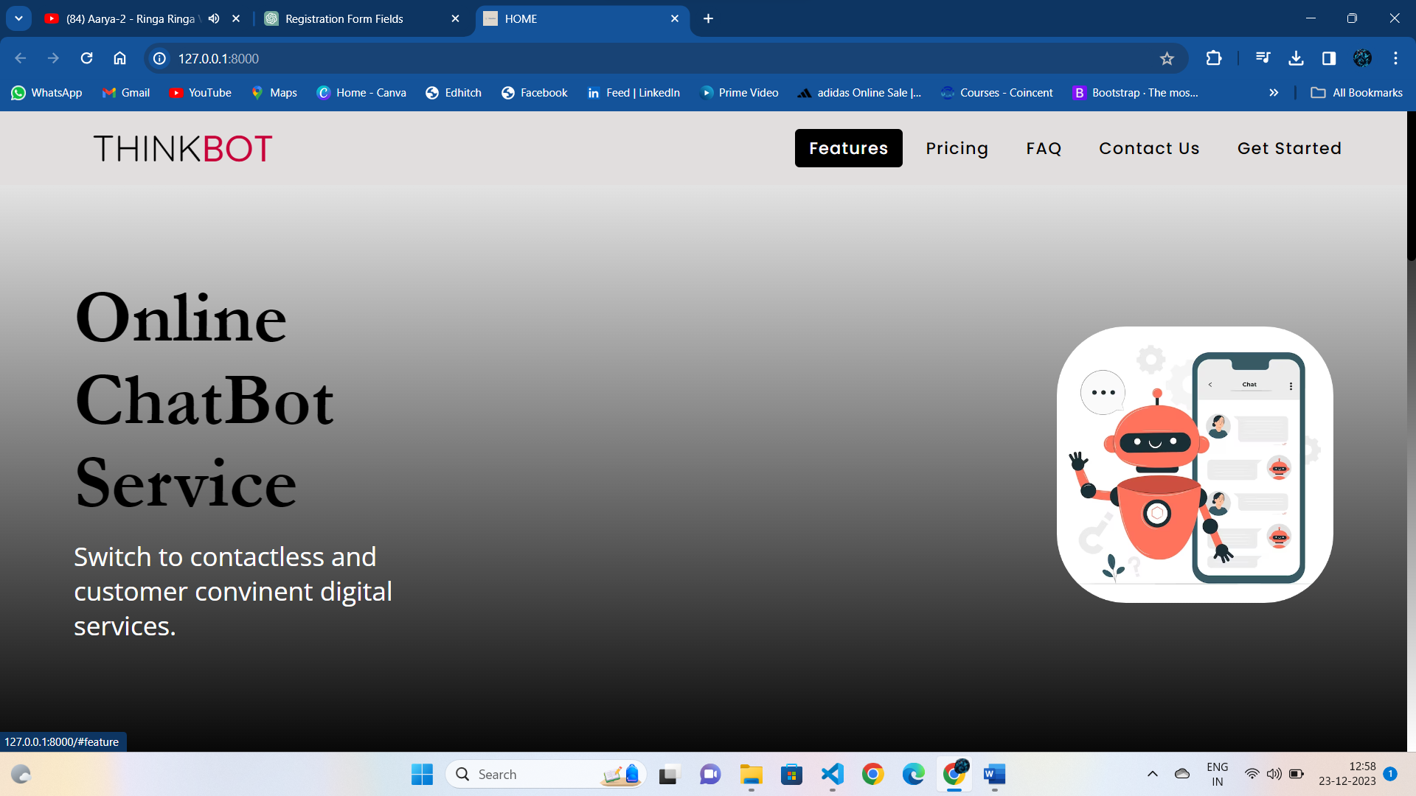

Fig 3.1: Home page

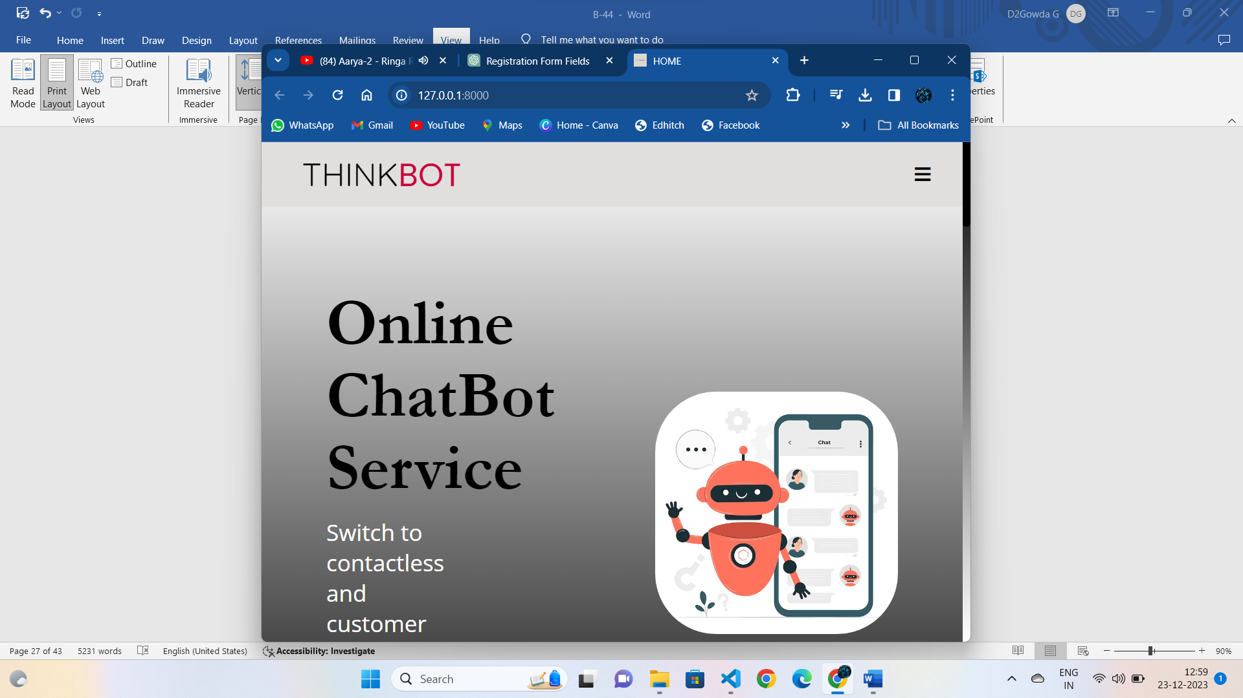

Fig 3.2: Home page(Responsive).

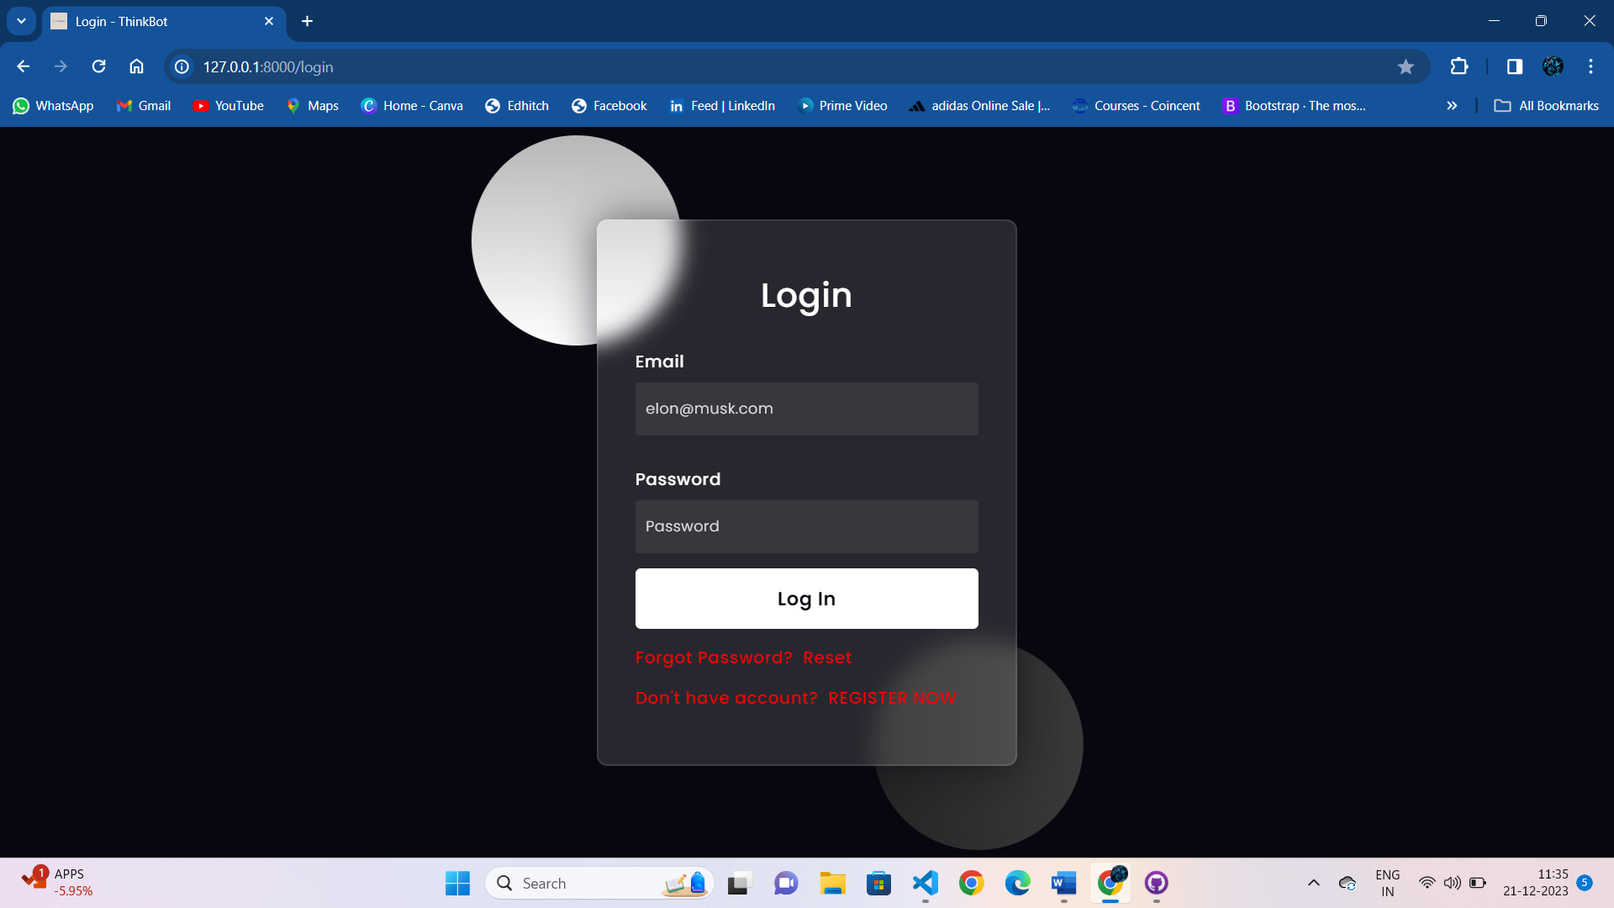

Fig 3.3: Login Page

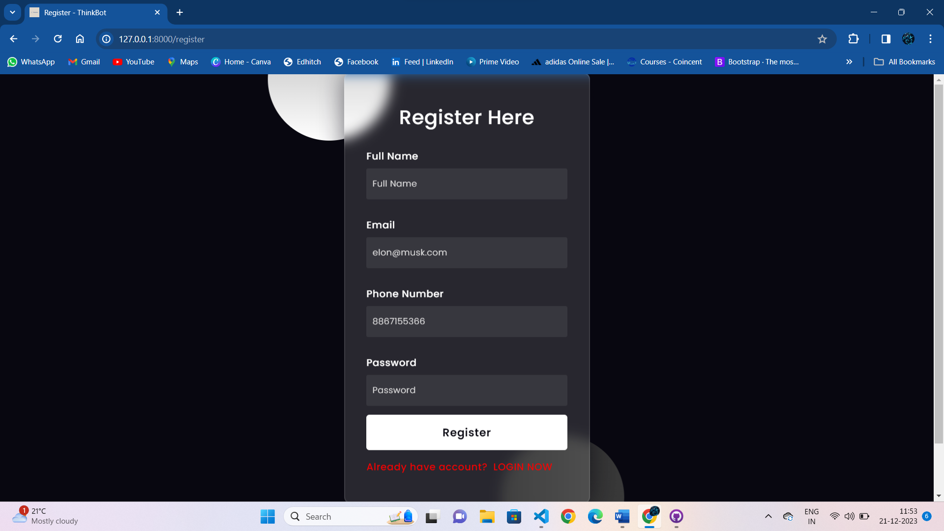

Fig 3.4: Register page

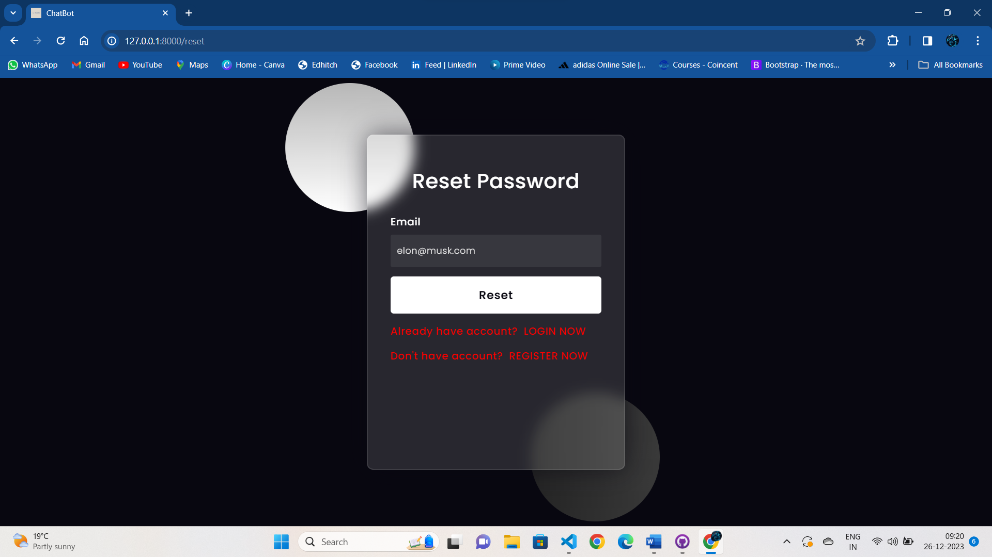

Fig 3.5: Reset pageTop of Form

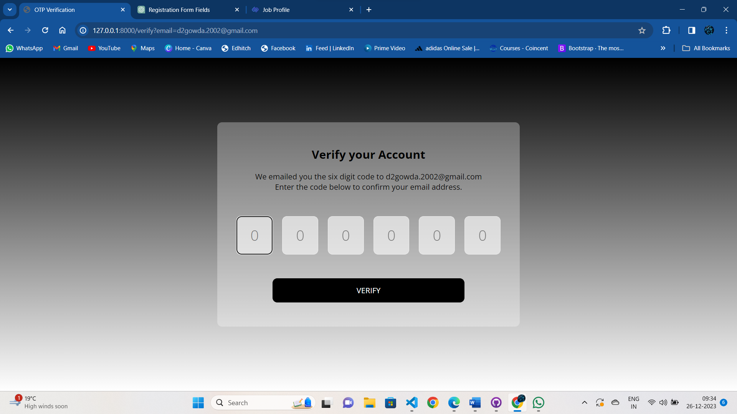

Fig 3.6: Otp page

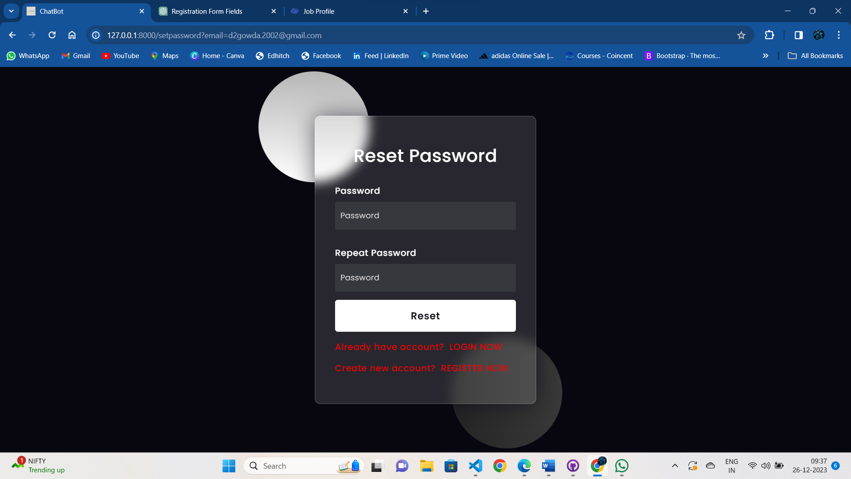

Fig 3.7: Set new password page

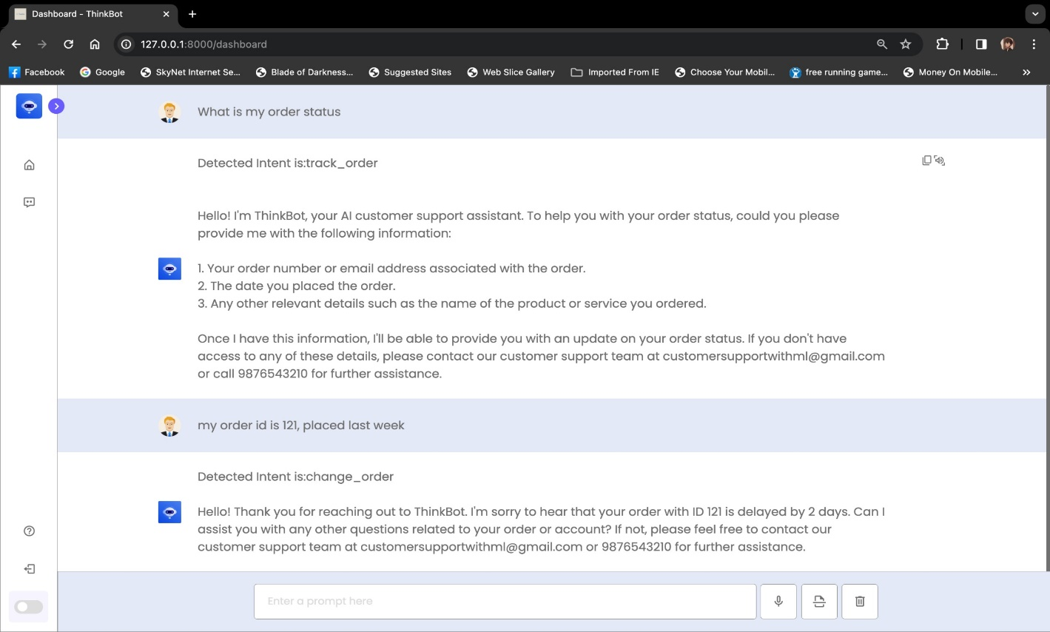

Fig 3.8: Dashboard Page

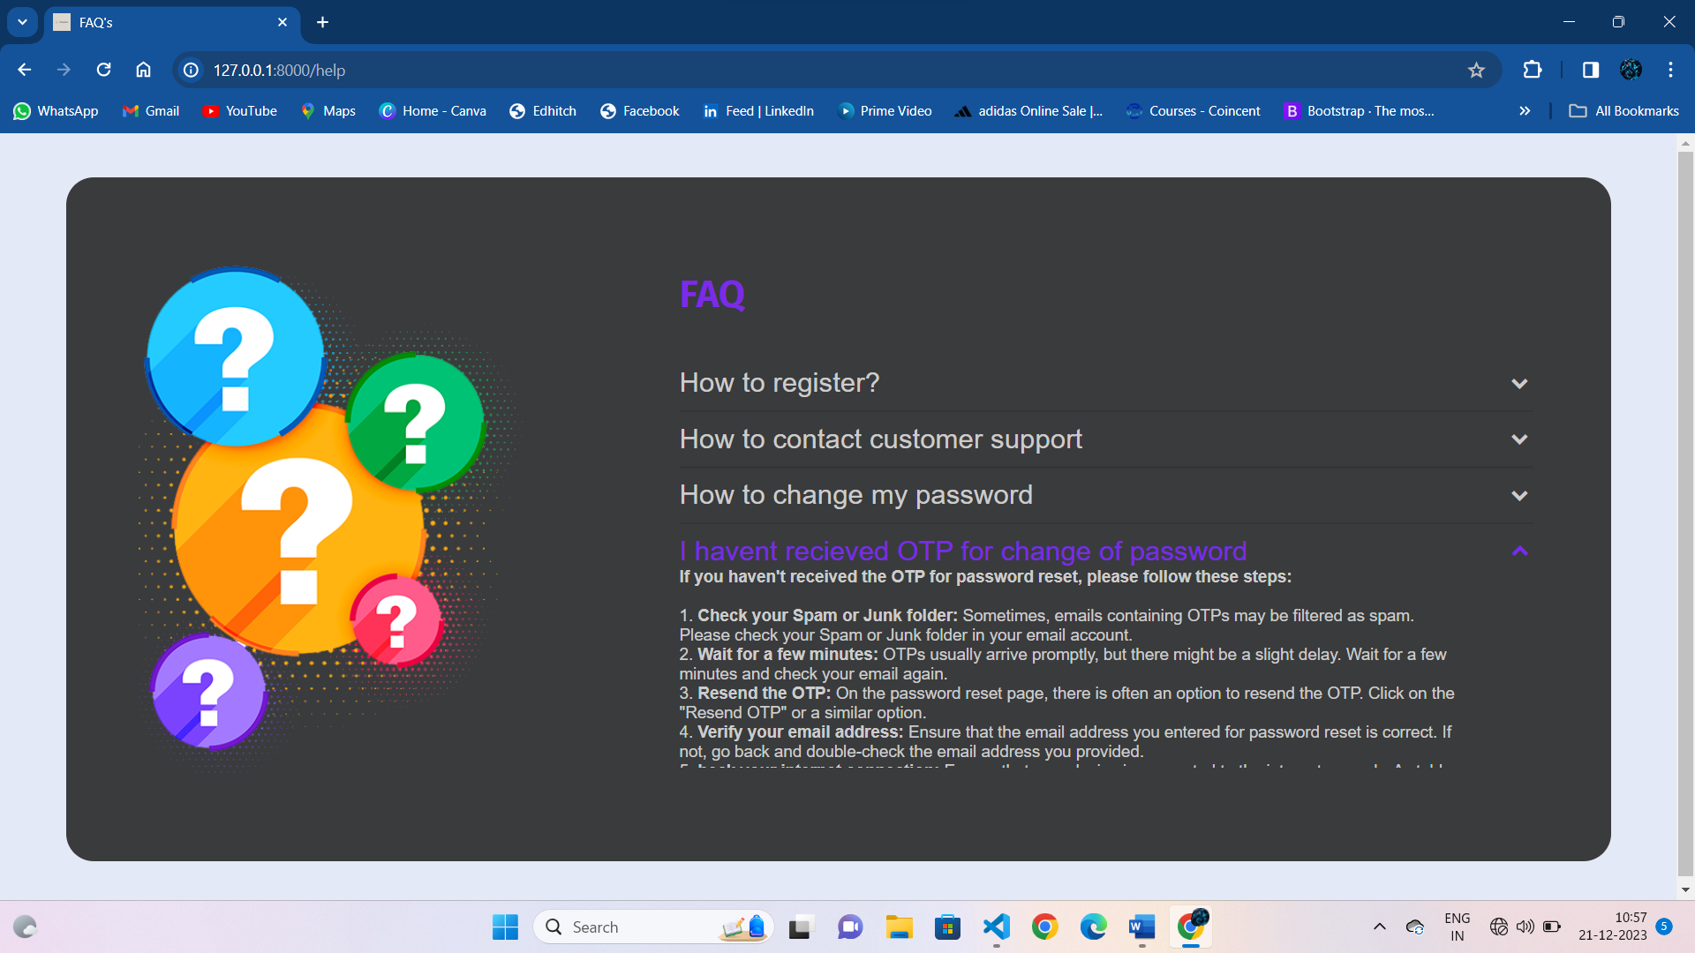

Fig 3.9: Help page

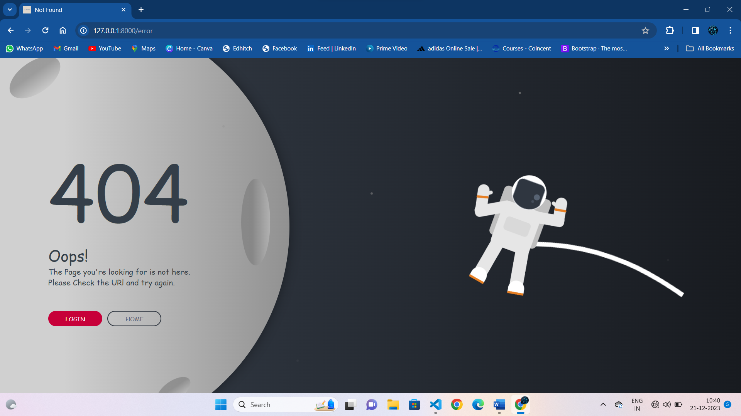

Fig 3.10: 404 error page

**APPENDIX-C**

**ENCLOSURES**

**Publication:**

Shaik Salma Begum, Vishal R, Darshan Gowda G, Jangam Dheeraj, Vishwas B, and Sankar Reddy (2023). "Customer Support Chatbot with Machine Learning" International Research Journal of Engineering and Technology (IRJET), Volume 10, Issue 12, Dec 2023, pp. [688-693]. e-ISSN: 2395-0056, p-ISSN: 2395-0072. URL: [www.irjet.net](http://www.irjet.net/)

Published Paper Link:

<https://www.irjet.net/archives/V10/i12/IRJET-V10I12101.pdf>

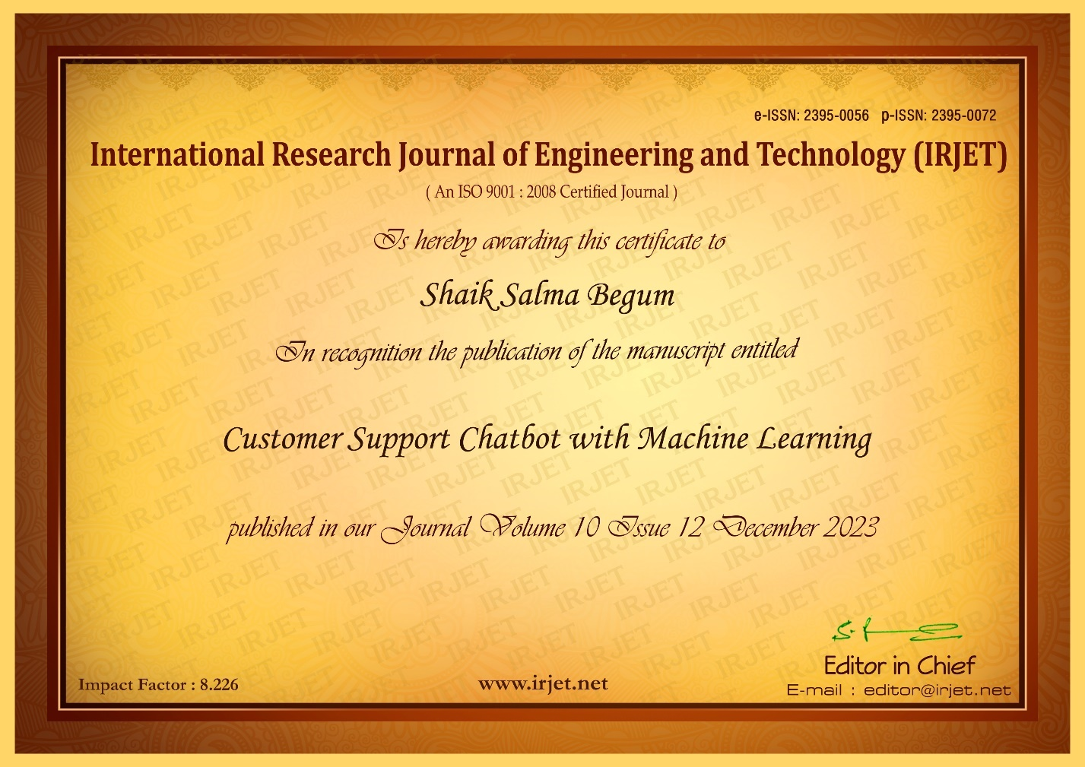

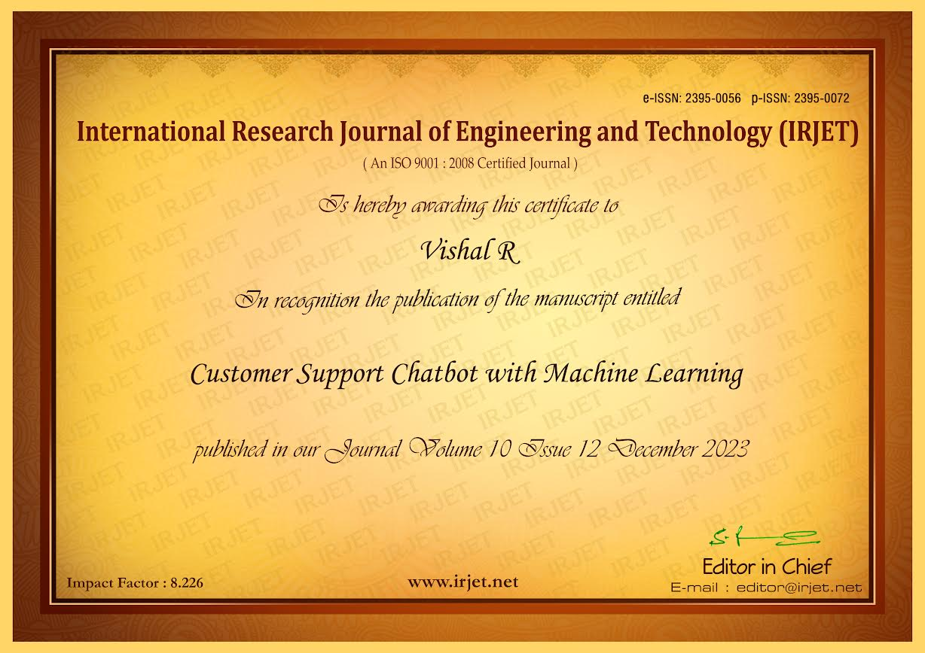

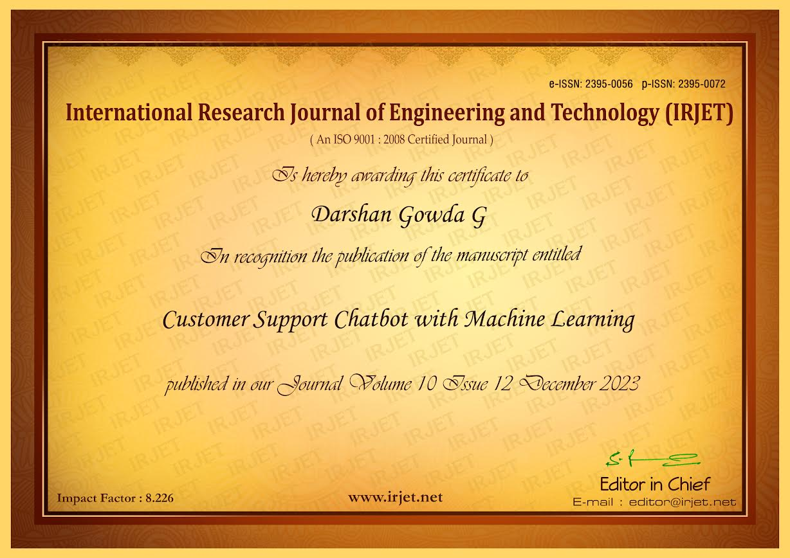

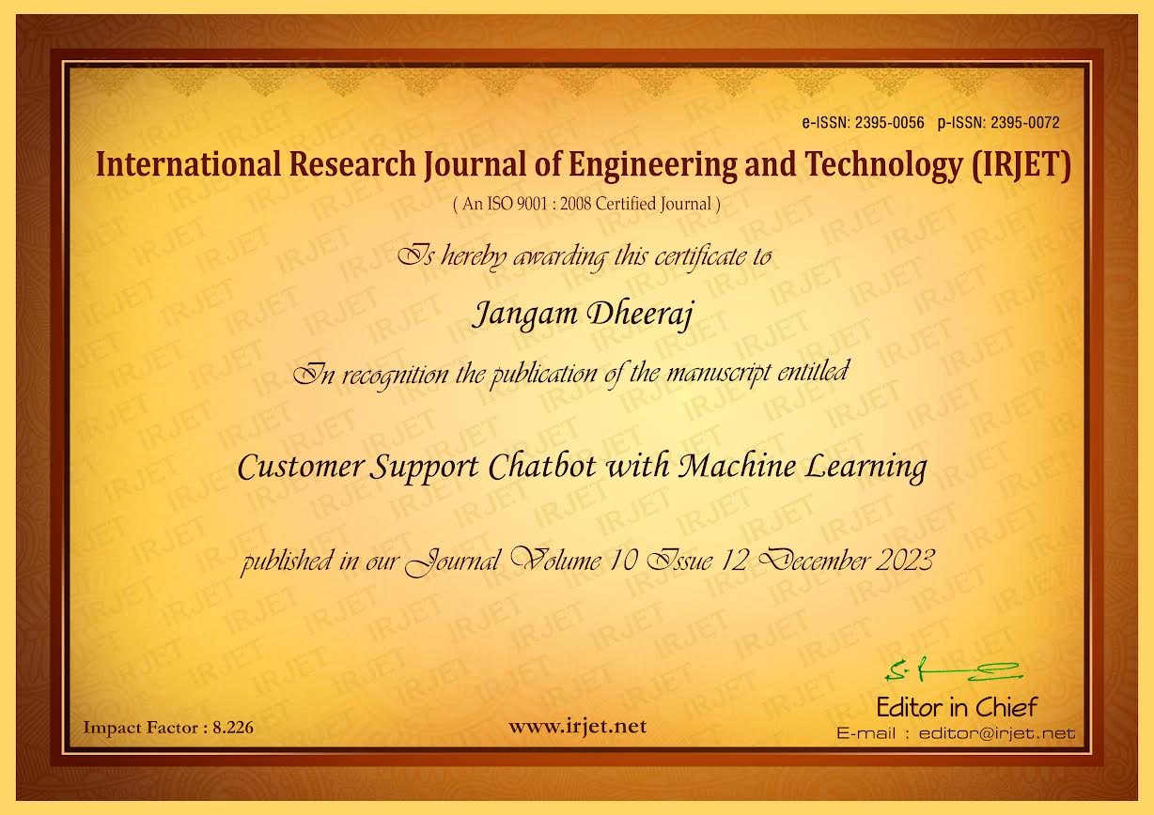

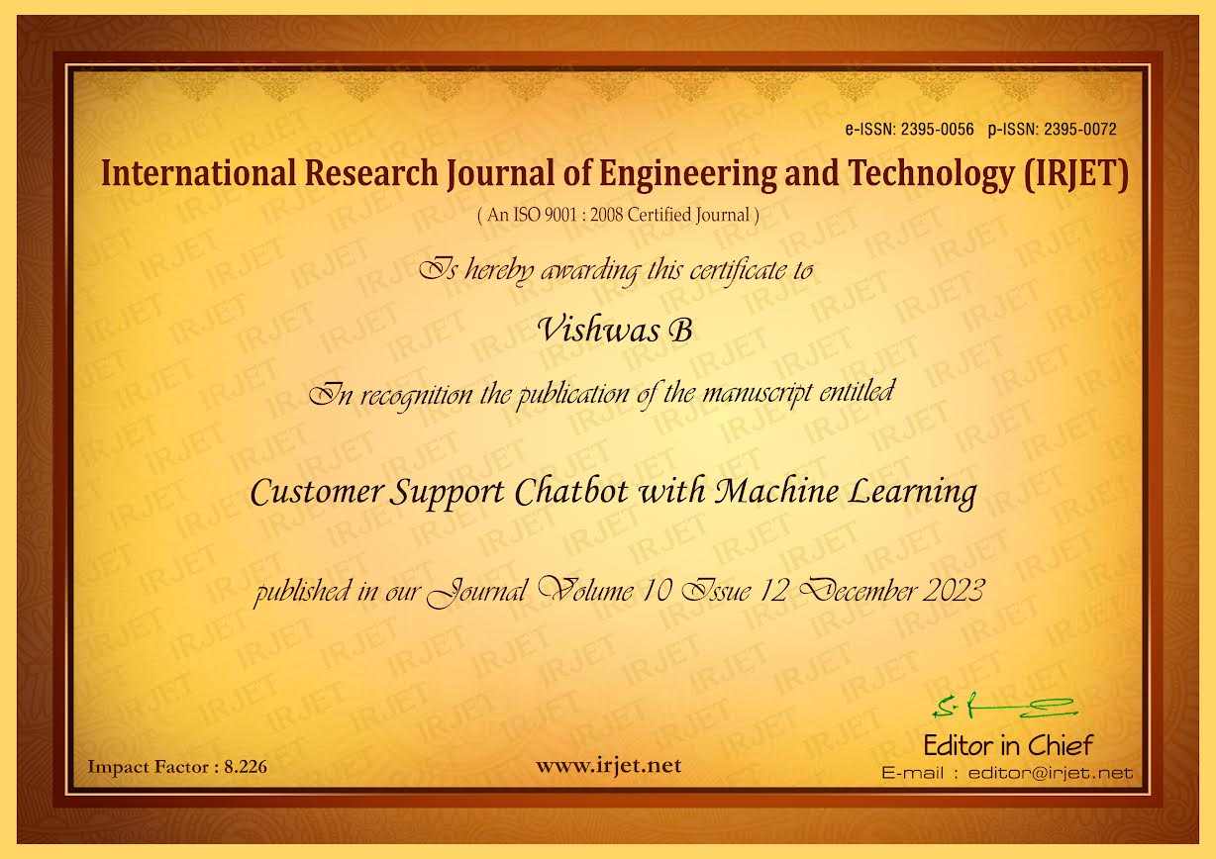

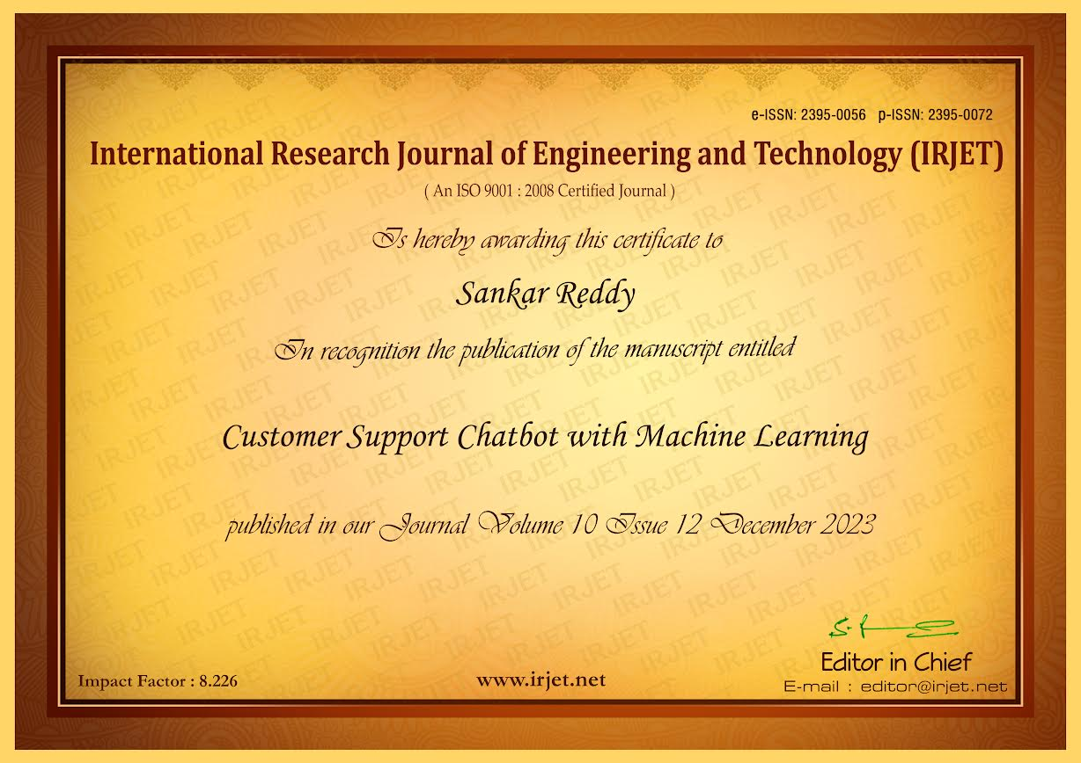

**Plagiarism Report**

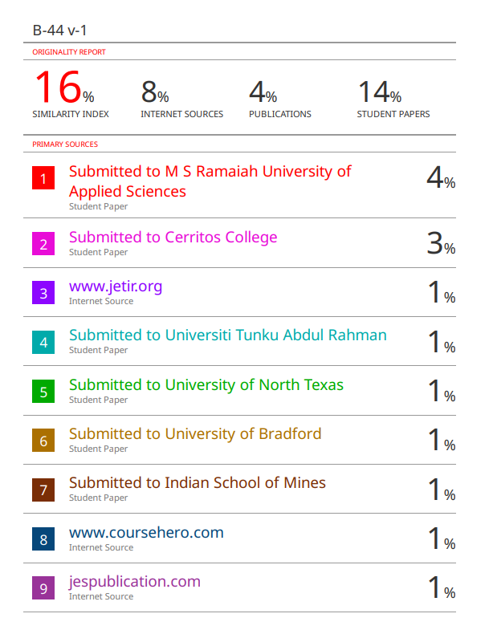

Fig 4.1: Plagiarism Report



**This Project work carried out here is mapped to SDG-9 INDUSTRY, INNOVATION AND INFRASTRUCTURE.**

This project work carried here contributes to the industry innovation and infrastructure. This can be used to study advancements in the field of chatbot with integrated machine learning and large language model which further can contribute for future studies in the field developing more accurate human friendly chatbot.